ECONOMICS
CHAPTER - 1
DEVELOPMENT
ASPECTS OF DEVELOPMENT

OF LIFE
Different notions of development:
- Different people have different notions of development because life situations of persons are different and therefore their aspirations and desires and goals.
- What may be development for one may not be development forthe other. It may even be
destructive for the other.
Income and other goals
- Money, or material things that one can buy with it, is one factor on which our life depends.
- The quality of our life also depends on non-material things.
- The developmental goals that people have are not only about better income but also about other
important things in life.
How to compare different countries or states?
- The Comparison between countries, total income is not such an useful measure.
- Countries have different populations, comparing total income will not tell us what an average person is likely to earn.
- We compare the average income which is the total income of the country divided by its total population.
- The average income is also called per capita income.
- In World Development Report 2006, Countries with per capita income of Rs 4,53,000 per annum and above in 2004, are called rich countries and those with per capita income of Rs 37,000 or less are called low-income countries.
- India comes in the category of low-income countries because its per capita
income in 2004 was just Rs 28,000 per annum.
- The rich countries, excluding countries of Middle East and certain other small countries, are
generally called developed countries.
Public facilities
- Money in your pocket cannot buy all the goods and services that you may need to live
well.
- Income by itself is not a completely adequate indicator of material goods and services that
citizens are able to use.
- For example, normally, your money cannot buy you a pollution-free environment or Money may also not be able to protect us from infectious diseases, unless the whole of your
community takes preventive steps.
Body Mass Index (BMI).
- Take the weight of the person in kg.
- Then take the height in metres.
- Divide the weight by the square of the height.
- If the figure is less than 18.5 then the person would be considered undernourished.
- If this BMI is more than 25, then a person is overweight.
Human Development Report
- Human Development Report published by UNDP compares countries based on the Educational levels of the people,
- Their health
- Status
- Per capita income.
Sustainability of development
- "Sustainable development is development that meets the needs of the present, without compromising the ability of future generations to meet their own needs."
- The concept of sustainable development is an approach to development that looks to balance different, and often competing, needs against an awareness of the environmental, social and economic limitations we face as a society.
Infant Mortality Rate (or IMR) indicates the number of children that die before the age of one year as a proportion of 1000 live children born in that particular year.
Literacy Rate measures the proportion of literate population in the 7 and above age group.
Net Attendance Ratio is the total number of children of age group 6-10 attending school as a percentage of total number of children in the same age group.

MULTIPLE CHOICE QUESTION
1. | For comparing the development of countries, their _______ is considered to be one of the most important attributes.  a) income  b) population  c) demographics  d) none of the above
2. | If the Body Mass Index (BMI) is _________ then the adult person would be considered undernourished.  a) less than 18.5  b) less than 10.5  c) less than 25.5  d) less than 28.5
3. | What will be the top priority in the developmental goal of a landless labourer?  (a) Expansion of rural banking  (b) More days of work and better wages  (c) Metal roads for transportation  (d) Establishment of a high school
4. | Which of the following neighbouring countries has better performance in terms of human development than India?  a) Bangladesh  b) Sri Lanka  c) Nepal  d) Pakistan
5. | What is the full form of UNDP?  a) United States National Development Project  b) Union National Global Development  c) United Nations Development Programme  d) Union of Nations for Global Development
6. | . …………….. is the total income of the country divided by its total population?  A. per capita income  B. Gross income  C. Net income  D. Total income
7. | Which of the following is the most important component for comparing different countries?  (a) Population  (b) Income  (c) Per capita income  (d) Resources
8. | Which one of the following statements defines ‘Literacy Rate’?  (a) Total literate population divided by total population  (b) Total literate population divided by literate population  (c) Proportion of illiterate population in the 18 and above age group.  (d) It measures the proportion of literate proportion in the 7 years and above age group
9. | Pick out the cause (from below) that enhances environmental degradation:  (a) Planting of trees.  (b) Prevention of factory wastes getting mixed up with river water.  (c) Ban on use of plastic bags.  (d) Allowing increase in the level of exhaust fumes emitted by cars, buses, trucks, etc.
10 | In which state of India is the infant mortality rate lowest?  (a) Punjab  (b) Bihar  (c) Uttar Pradesh  (d) Kerala
11. | Which category does India come under?  A. High-income countries  B. Low middle-income countries  C. Low-income countries  D. High middle-income countries
12. | Groundwater is an example of …………..resources?  A. Renewable  B. Non-renewable  C. Protected  D. Reserve
13. | ANSWERS:  1---- (a) 2----(b) 3 ---(b) 4 ---(c) 5 ---(a)  6 --- (c) 7----(d) 8 ---(a) 9 ---(d) 10 --(d)  11 --(b) 12----(a)
14. | Fill in the blanks :  1)PDS means _______________________  2) Human Development Report is published by ________________  3) Two important aspects of our lives other than income are _________ and _____________  4) ____________ is the most common indicator for measuring economic development of a country.  5) IMR stands for _________________  6) Infant Mortality Rate (or IMR) indicates the number of children that die before the age of ____________ as a proportion of 1000 live children born in that particular year.  7) In India, ___________ state has the lowest literacy rate.  8) Nearly ___________ of the country is overusing their ground water reserves.  ANSWERS:  - Public Distribution System  - the United Nations Development Programme (UNDP)  - Equality and freedom  - Per capita income  - Infant Mortality Rate  - 1 year  - Bihar  - One-third
15. | ASSERTION AND REASONING:  ASSERTION(A): Kerala has low Infant Mortality Rate.  Reason ( R) : Kerala has adequate provision of basic health and education facilities.  - Both Assertion (A) and Reason (R) are true and Reason (R) is the correct explanation of Assertion (A) .  - Both Assertion (A) and Reason (R) are true but Reason (R) is not the correct explanation of Assertion (A) .  - Assertion (A) is true but Reason (R) is false.  - Assertion (A) is false but Reason (R) is correct.  Answer: Option (a)
 | 3 Mark questions:
1. | What is per capita income? Mention any two limitations of per capita income as an indicator of development.  Answer-  - The total income of a country divided by its total population gives the percapita income.  - The rise in per capita income is due to a rise in prices. An increase in physical output has no contribution, therefore, it is not a reliable index of economic development.  Per capita income doesn't tell us how the income is distributed among people.  Per capita income cannot be regarded as the sole indicator of development. Other Ares are also important like literacy rate, life expectancy, infant mortality rate, etc.
2. | “What may be development for one may not be development for the other.” Explain with a suitable example.  Answer:  Every individual is different from each other, the notion of development also varies. The difference in social and economic positions of the people generally results in different goals of development. Two individuals and groups of people may have conflicting interests.  - For example, for many people, large dams are the symbols of development and prosperity. However, building of large dams results in the displacement of villagers and tribals from their homes and land. They not only lose their land and homes but also their livelihood. Therefore, villagers often resent and protest against the building of large dams.  - The ‘Narmada bachao andolan’ is one such case, where villagers and tribals have been opposing the construction of the dam.
3. | Explain the term ‘Development. How is it linked with sustainability ? Explain with example.  Answer:  (i)Development is a process which has a notion of going further up and improving the quality of life.  (ii) It is linked to sustainability since it has to be maintained for future generations.  (iii) Resources need to be used wisely so that they can be replenished.  (iv) Overuse of resources exhausts them. For example, petroleum.  (v) If development is not sustainable, it will give rise to environmental degradation and become a global problem.
4. | 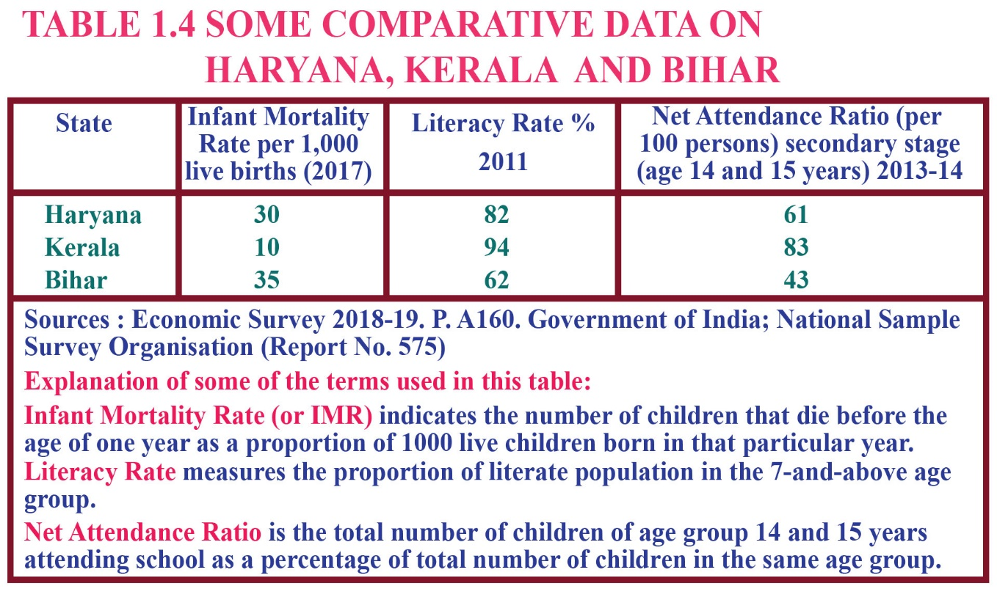
5. | Define the following based on the information given in the above table  - Infant mortality rate  - Literacy rate  - Net attendance ratio  - Name the state which has maximum% of net attendance ratio  Answer:  - Infant mortality rate. It indicates the number of children that die before the age of 1 year as a proportion of 1000 live children born in that particular year.  - Literacy rate. It measures the proportion of literate population in the 7 and above age group.  - Net Attendance ratio. It is the total number of children of age group 6 to 10 attending school as a percentage of total number of children in the same age group.  Kerala
6. | Why do people look at a mix of goals for development? Explain.  Answer:  Though income is one of the most important components of development, but there are other important goals which people look at for development—  - People also seek things like equal treatment, freedom, security and respect.  - Women need a safe and secure environment to take up a variety of jobs or to run businesses as entrepreneurs.  - People seek a pollution free environment.  - Students seek better education and equal opportunities to learn.
7. | “The Earth has enough resources to meet the needs of all but not enough to satisfy the greed of even one person”. How is this statement relevant to the discussion of development? Discuss.  Answer:  “The Earth has enough resources to meet the needs of all but not enough to satisfy the greed of even one person”. This statement is given by Mahatma Gandhi and is relevant to the discussion of development since both resources and development go hand in hand.  For the sustainability of development, the maintenance of resources is also crucial. As the statement claims, the Earth has enough resources—renewable and non-renewable—to satisfy everyone’s needs; however, these need to be used with a view to keeping the environment protected and clean so that a balance of production and use is maintained, and shortages are avoided.
8. | What do you mean by public facilities? Why are they important? Name two public facilities available in India.  Answer:  - Public facilities are the essential facilities for the community at large and are provided by the government Important:  - They are important because there are many services like education, health, transportation etc., which have become cheap and affordable if provided, collectively.  - Public facilities : Rail transport and – Government schools.
9. | Why do we use averages? Are there any limitations to their use?  Illustrate with your own examples related to development.  Answer:  a) Total income is not a useful measure for comparison between countries.  Since countries have different populations, comparing total income does not tell what an average person is likely to earn. Hence, we use average income which is total income of the country divided by total population.  b) The defect of average as a measure is that it does not show the distribution (dispersion) of income between the rich and the poor.  c).Two countries may have the same average income but in one country almost every family may enjoy more or less the same kind of income, whereas in the other, some maybe very rich and others very poor.  d) The disparity between rich and poor is an important  feature that the average measure (per capita income) does not consider. Example: In terms of development, we can take the example of India, where the metro towns are full of high-rise buildings and shopping malls while some villages have not yet been provided with a basic necessity like electricity.
 | 5 Mark questions:
1. | “Money cannot buy all the goods and services that one needs to live  well” Do you agree with this statement? Justify your answer with any three suitable arguments.  Answer: Yes, I agree with the statement because money income and material goods alone are not an adequate indicator of a good quality of life. Money cannot buy all the goods and services one needs to live well.  • Money cannot buy pollution free and dean environment with fresh air.  • It cannot protect us from infectious diseases and guarantee good health for us.  • Money cannot assure that medicines available in the market are not adulterated. To live well one needs non-material factors such as equal treatment, freedom, security, equal opportunity to learn, a pollution free environment, good and safe working conditions etc.
2. | What is the main criterion used by the World Bank in classifying different countries? What are the limitations of this criterion, if any?  Answer:  The criterion used in classifying countries is the per capita income of a nation. This criterion is used by the World Bank in its World Development Reports.  - Countries with per capita income of US$ 1035 or less are called low-income countries.  As per 2012, rich countries are the countries with per capita income of US$ 12616 per annum and above.  In 2012 per capita income of India was just US$ 1530 per annum, hence it was classified in the category of low middle income countries.  Generally developed countries are the rich countries, excluding some small countries and countries of the Middle East.  Per capita income is nothing but the average income.  Average income is the total income of the country divided by its total population. Hence, the right measure used in comparing different nations is comparison of average incomes of nations.  Limitations  Better income is the only goal for people. They have many other goals in life such as freedom, equal treatment, respect for other people, security etc. There are a whole gamut of things which are not included in the criterion used by the World Bank for comparing countries.  For example, one cannot say everything is fine and developed by merely checking the per capita income, there are other factors like infant mortality rate which needs to be measured.  Health, Nutrition, Education levels are other important metrics which are not measured through the development report given out by the World Bank.  Unless the whole of your community takes preventive steps, money may not be able to protect a person from infectious diseases  Money cannot ensure that you get unadulterated medicines.  Money alone cannot buy you a pollution-free environment.
3. | What are the importance of Human development index?  Answer:  - It indicates the development of a country.  - It indicates to a country how far it has to yet travel to achieve a higher rank and how far itas travelled.  - It indicates the country that in which areas it is poor and in which areas it has improved.  - Though it, one comes to know the important elements of economic welfare like life Expectancy, level of education attainment and real per capita income.  - It measures material and non material components of development.  - Human Development Index is helpful for a country to plan its future agendas.
Mention any four aspects of comparison notions of development between different countries. Or
Explain three attributes for comparing nations development between different countries. Or
What are the two basic criteria used for comparing an underdeveloped country with developed one ? Or
Give examples to prove that there are other important developmental goals than income.
Answer: Development of a country can generally be determined by: per capita income; average literacy level; and health status of its people.
(i) Per Capita Income means average income generated by each person in a given group of people. Its limitation is that it does not show the disparities among the people of the group. ‘
(ii) Amount of literacy achieved is also a measure of development. Literacy rate measures the proportion of literate population in the 7 and above age group. The more the people are educated, the more the country will be developed.
(iii) Health indicators are Infant Mortality Rate, Birth Rate, etc. Lower the amount of Infant Mortality Rate, higher is the rate of people being healthy. ,
(iv) Net Attendance Ratio is also the indicator of economic development of a nation. It is the total number of children of age group 6-10 attending school as a percentage of total number of children in the same age group,
(v) Life Expectancy at birth denotes average expected length of life of a person at the time of birth. Higher the life expectancy at birth, higher is considered the development of a nation.

CHAPTER -2

SECTORS OF THE INDIAN ECONOMY

Gross Domestic Product (GDP)
- The value of final goods and services produced in each sector during a particular year provides the total production of the sector for that year.
- The sum of production in the three sectors gives Gross Domestic Product (GDP) of a country.
- GDP is the value of all final goods and services produced within a country during a particular year.
- It shows how big the economy is. In India, the task of measuring GDP is undertaken by a central government ministry.

The graph below shows the production of goods and services in the three sectors.

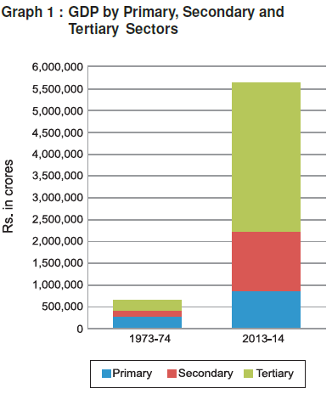

IMPORTANCES OF TERTIARY SECTOR
- Services such as hospitals, educational institutions, post and telegraph services, police stations, courts, village administrative offices, municipal corporations, defence, transport, banks, insurance companies, etc. are considered as basic services and are necessary for all people.
- The development of agriculture and industry leads to the development of services such as transport, trade, storage etc.
- With the rise in the income of people, they start demanding more services like eating out, tourism, shopping, private hospitals, private schools, professional training etc.
- Over the past decade, certain new services based on information and communication technology have become important and essential.

Where are Most People Employed
PRIMARY SECTOR | SECONDARY SECTOR | TERTIARY SECTOR
- More than half of the workers in India are working in the primary sector, mainly in agriculture. | - These sectors employ less than half the people as compared to the primary sector.
- It contributes only a quarter of the GDP. | - These sectors produce four-fifths of the product.

Mahatma Gandhi National Rural Employment Guarantee Act (MGNREGA) 2005.
- The central government in India made a law implementing the Right to Work in about 625 districts of India, which is called Mahatma Gandhi National Rural Employment Guarantee Act (MGNREGA) 2005.
- Under MGNREGA 2005, all those who are able to, and are in need of work in rural areas are guaranteed 100 days of employment in a year by the government. If the government fails in its duty to provide employment, it will give unemployment allowances to the people.

DIVISION OF SECTORS

ORGANISED SECTOR | UNORGANISED SECTOR
- It is a sector where the employment terms are fixed and regular, and the employees get assured work. | - The unorganised sector is characterised by small and scattered units, which are largely outside the control of the government.
- It is a sector where the employment terms are fixed and regular, and the employees get assured work. | - There are rules and regulations but these are not followed since they are not registered with the government.
- They are registered by the government and have to follow its rules and regulations, which are given in various laws such as the Factories Act, Minimum Wages Act, Payment of Gratuity Act, Shops and Establishments Act etc. | - Jobs are low-paid and often not regular.
- The job is regular and has fixed working hours. If people work more, they get paid for the overtime by the employer. | - Employment is not secure. People can be asked to leave without any reason.
- Workers enjoy the security of employment. | - There is no provision for overtime, paid leave, holidays, leave due to sickness etc.
- People working in the organised sector get several other benefits from the employers such as paid leave, payment during holidays, provident fund, gratuity etc. | - There are no such facilities in the unorganised sector.
- People get medical benefits. The factory manager has to ensure facilities like drinking water and a safe working environment. When they retire, these workers get pensions as well.
- Examples of the organised sectors are Government employees, registered industrial workers, Anganwadi workers, village health workers etc. | - Examples of the unorganised sectors are Shopkeeping, Farming, Domestic works, Labouring, Rickshaw pulling, etc.

ORGANISED SECTOR

UNORGANISED SECTOR

PROTECTION OF WORKERS IN UNORGANISED SECTOR
- The government can fix the minimum wages rate and working hours.
- The government can provide cheap loans to self-employed people.
- Government can provide cheap and affordable basic services like education, health, food to these workers.
- The government can frame new laws which can provide provision for overtime, paid leave, leave due to sickness, etc.

SECTORS IN TERM OF OWNERSHIP

PUBLIC SECTOR | PRIVATE SECTOR
- In the public sector, the government owns most of the assets and provides all the services. | - In the private sector, ownership of assets and delivery of services is in the hands of private individuals or companies.
- Railways or post office is an example of the public sector. | - Companies like Tata Iron and Steel Company Limited (TISCO) or Reliance Industries Limited (RIL) are privately owned companies.
- The purpose of the public sector is not just to earn profits. Its main aim is public welfare. | - Activities in the private sector are guided by the motive to earn profits.

RESPONSIBILITIES OF GOVERNMENT
- Government raises money through taxes and other ways to meet expenses on the services rendered by it.
- Governments have to undertake heavy spending such as the construction of roads, bridges, railways, harbours, generating electricity, providing irrigation through dams etc. Also, it has to ensure that these facilities are available for everyone.
- There are some activities, which the government has to support to encourage the private sector to continue their production or business.
- The government in India buys wheat and rice from farmers at a ‘fair price’ and sells at a lower price to consumers through ration shops. In this way, it supports both farmers and consumers.
- Running proper schools and providing quality education, health and education facilities for all are some of the duties of the government.
- Government also needs to pay attention to aspects of human development such as availability of safe drinking water, housing facilities for the poor and food and nutrition, taking care of the poorest and most ignored regions of the country.
MULTIPLE CHOICE QUESTIONS
1. | Which of the following activities does not belong to the primary sector?  (a) Fishing  (b) Banking  (c) Mining  (d) forestry
2. | Which of the following sectors is the largest employer in India?  (a) Primary Sector  (b) Secondary Sector  (c) Tertiary Sector  (d) IT Sector
3. | The task of measuring GDP is undertaken by the  (a) central government  (b) state government  (c) provincial government  (d) all of the above  The motive of the public sector enterprises is  (a) profit making  (b) entertainment  (c) social welfare and security  (d) none of the above
4. | NREGA (National Rural Employment Guarantee Act of 2005) has guaranteed ………. days of employment in a year in many districts of India. What are the correct number of days?  (a) 200 days  (b) 100 days  (c) 30 days  (d) 60 days
5. | Which of the following examples does not fall under unorganized sector?  (a) A farmer irrigating his field.  (b) A daily wage labourer working for a contractor.  (c) A handloom weaver working on a loom in her house.  (d) A doctor in a hospital treating a patient.
6. | The money value of all final goods and services produced within a country during a particular year is called:  (a) Gross domestic product  (b) Net domestic product  (c) National product  (d) Production of secondary sector
7. | What is meant by GDP?  (a) Gross Dairy Product  (b) Gross Domestic Product  (c) Great Development Project  (d) Great Domestic Product
8. | The sectors are classified into public and private sector on the basis of:  (a)employment conditions  (b)the nature of economic activity  (c)ownership of enterprises  (d)number of workers employed in the enterprise
9. | Which of the following is not applicable for a worker, who works in the organised sector?  (a) She gets a regular salary at the end of the month  (b) She is not paid for leave  (c) She gets medical allowance  (d) She got an appointment letter stating the terms and conditions of work when she joins work.
10. | .What are the groups of classification of an economy called?  (a) Sectors  (b) Centres  (c) Types  (d)Categories
11. | When we produce a good by exploiting natural resources it is called……..?  (a) Tertiary sector  (b) Primary sector  (c )Service sector  (d) Public sector
12. | Using sugarcane as raw material, we make sugar or gur, under what sector does this activity come?  (a) Primary  (b) Industrial  (c)Tertiary  (d) None of these
13. | Choose one correct statement from the following:  Underemployment occurs —  (a) when people are not willing to work.  (b) when people are working slowly.  (c) when people are working less than what they are capable of doing.  (d) when people are not paid for their jobs.
14. | Which sector has emerged as the largest producing sector in India. Select one from the following alternatives:  (a) Secondary sector  (b) Tertiary sector  (c) Primary sector  (d) Science and Technology sector
15. | Where will you find the disguised unemployment most? Select the correct option from those given below:  (a) Among agricultural workers working for small farm lands  (b) Among part-time industrial workers  (c) In most of the government offices  (d) In big private companies.
16. | Which of the following comes under the tertiary sector?  a) transport  b) communication  c) both (a) & (b)  d) none of the above
17 | The National Rural Employment Guarantee Act was passed by the Government of India in __  a) 2005  b) 2010  c) 2004  d) 2014
18. | Which one of the following occupation is not associated with primary sector ?  (a) Basket Weaver  (b) Potter  (c) Gardener  (d) Priest
19 | In which type of unemployment more people are employed than required?  (a)seasonal unemployment  (b)disguised unemployment  (c ) educated unemployment  (d) all the above
ANSWERS:
1.(b) 2. (a) 3.(a) 4. (c ) 5.(b) 6.(d) 7. (a) 8.(b) 9. (c ) 10.(b) 11.(a) 12. (b)
13. (b) 14. (c ) 15. (b) 16. (a) 17. (c ) 18. (a) 19. (d) 0. (b)
 | Fill in the blanks with suitable words:
1. | a) Workers in the _________ sector do not produce goods. (tertiary / agricultural)  b) Most of the workers in the _________ sector enjoy job security. (organised / unorganised)  c) A _________ proportion of labourers in India are working in the unorganised sector.  (large / small)  d) Cotton is a _________ product and cloth is a _________ product. [natural /manufactured]  e) The activities in primary, secondary and tertiary sectors are_________ [independent / interdependent]  f) Tertiary sector is also called ……….. .[Primary sector / Service sector]  g)Communication and banking come under ……….. sector.[Primary sector / Tertiary sector]  h) Cotton cultivation falls under ……….. sector..[Primary sector / Tertiary sector]  i) In the public sector, the ……….. owns most of the assets and provides all services.[Government / Private]  j) In the Private sector, the ownership lies in the hands of ……….. .[Government companies / Private companies]  k) Most of the jobs are ……….. and ……….. paid in the unorganised sector.[secure, highly/unsecure, lowly]  l) Protection and support to the unorganised sector is needed for both ……….. and ……….. development.[ economic and social / non-economic and personal]  m) Bankers and truck drivers belong to ……….. sector of the economy.[Secondary sector / Tertiary sector]  ANSWERS:  a) tertiary h) Primary sector  b) organised i) Government  c) large j) Private companies  d) natural,manufactured k) unsecure, lowly  e) interdependent l) economic and social  f) Service sector m) tertiary sector  g) Tertiary sector
2. | Assertion and Reasoning:  Assertion (A): Disguised unemployment is hidden in contrast to someone who does not have a job and is clearly visible as unemployed. Everyone is working, no one is fully employed.  Reason (R): In actual fact, labour effort gets divided.  - A) If both assertion (A) and reason (R) are true and reason (R) is the correct  explanation of assertion (A).  - (B) If both assertion (A) and reason (R) are true but reason (R) is not the correct  explanation of assertion (A).  - (C) Assertion (A) is true but reason (R) is false.  - (D) Both assertion (A) and reason (R) are false.  Answer- (B) If both assertion (A) and reason (R) are true but reason (R) is not the correct explanation of assertion (A).
3. | Assertion (A) Under MNREGA 2005, those who are able to and are in need to work in rural areas are guaranteed 100 days of employment in a year.  Reason (R) The Central Government in India made a law implementing the Right to Work in about 625 districts of India.  - (A) both Assertion (A) and Reason (R) are true and Reason (R) is the correct explanation of Assertion (A) .  - (B) both Assertion (A) and Reason (R) are true but Reason (R) is not the correct explanation of Assertion (A) .\  - (C) Assertion (A) is true but Reason (R) is false.  - (D) Assertion (A) is false but Reason (R) is correct.  Answer- (B) both Assertion (A) and Reason (R) are true but  Reason (R) is not the correct explanation of Assertion (A)
 | 3 MARK QUESTIONS
1. | 1) Explain the interdependence of all three sectors giving examples from transportation system.  Answer: All the three sectors, primary, secondary and tertiary, are interdependent to each other in the following ways.  - Primary sector makes possible the extraction of natural resource like iron. This iron is then taken to the secondary sector for manufacturing through the transportation system like trucks. The extraction process is supported by the financing and information technological institutions.  - It is through the secondary sector that the natural resource iron is changed into other forms through the process of manufacturing. Manufacturing again need the support of the service sector in the form of engineers, electricians, etc.  - Iron is changed into iron sheets and then into vehicles for transportation. Once manufactured, the vehicles are sold through various trading agencies. These vehicles are used for providing services in the tertiary sector and at the same time .
What constitutes the unorganized sector in urban areas? Why do workers in this area need protection?
Answer:
- In the urban areas, unorganised sector comprises mainly small-scale industry, casual workers in construction, trade and transport, street vendors, head-load workers, garment makers, ragpickers, etc. All these workers constitute unorganized sector in urban areas.
- A majority of workers in the unorganized sector are from scheduled castes scheduled tribes and backward communities.
- Workers in unorganised sector urban areas need protection because, besides getting the irregular and low- paid work, these workers also face social discrimination.They are looked down upon by the people in urban areas.
- Protection and support to the unorganised sector workers is thus necessary for both economic and social development.
How does service sector help in the development of primary and secondary sectors? Explain with examples.
Answer:
- After primary and secondary sectors, there is a third sector called the service sector also known as tertiary sector.
- Activities that fall under the service sector help in the development of the primary and secondary sectors by not directly producing a good but helping these sectors by activities that are an aid or a support for the production process.
- For example, goods that are produced in the primary or secondary sector would need to be transported by trucks or trains and then sold in wholesale and retail shops.
- At times, it may be necessary to store these goods in godowns. We may also need to talk to others over telephone or send letters (communication) or borrow money from banks (banking) to help production and trade.
- Transport, storage, communication, banking and trade are some examples of service or tertiary sector. Since these activities generate services rather than goods, they promote primary and secondary sectors by providing expertise, finance, transportation, advertisement, etc
Explain with suitable examples which part of the service sector is not growing in importance. Answer:
- The employment generation part of service sector is not growing in importance. The service sector in India employs different kinds of people.
- At one end, there are a limited number of services that employ highly skilled and educated workers. At the other end, there are a very large number of workers engaged in services such as small shopkeepers, repair persons cattle, owners transport drivers and electricians.
- These people barely manage to earn there living and yet they perform these services because no alternative opportunity for work are available for them.
Highlight the three factors responsible for the growth of service sector in the Indian economy.
Answer:
Ever since the service sector got liberalized in the year 1991, it has seen constant growth. The following are the reasons responsible for the growth of service sector in the Indian economy.
- Increase in the income of people: Since the income level of the people has been increasing ever since, with increasing affluence there is increase in the demands of the services like maids, cooks, servants and gardeners.
- Increase in population: With an increase in number of people in the country, the demand for service sector has increased. Demands for service like schools, health department and nursing homes have increased.
- Increase in numbers of working women: With the passage of time there has been a massive increase in the number of working women in India. This has led to increase in demands in the service sector like household help, babysitters and cooks.
How to Protect the workers under Unorganised Sector?
ANSWER:
- There are many groups of vulnerable people who need protection in the unorganised sector.
- In rural areas farmers can be supported through adequate facilities for timely delivery of seeds, agricultural inputs, credit, storage etc.
- In urban areas the small scale industries can be protected by governments support for procuring raw materials and marketing of output.
- Protection and support to farmers and workers are necessary for economic and social development.
 | 5 MARK QUESTIONS:
1. | Explain disguised unemployment with two examples, one from urban areas and other from rural areas.  Answer:  - Disguised unemployment is a kind of unemployment in which some people look like being employed but are actually not employed fully.  - This situation is also known as hidden unemployment.  - It refers to a situation wherein more people are engaged in a work than required. When the surplus workers from a rural area engaged in the activity or the work, are removed, the production remains unaffected.  - In urban areas, there are many people who are employed. Their jobs do not suit their qualifications. Disguised unemployment can be seen in the service sector where painters, repair person, plumber, etc. are doing odd jobs. Many of them do not find work on a daily basis. Taking an example, there is a shop, which require only two persons for handling it, but if there are three servants and one owner to look after the shop, then this shows that two servants are in the situation of disguised unemployment.  - In rural areas, disguised employment can be seen in the agricultural sector. Most often, all the members of a family are engaged on the same piece of land. If a few members are withdrawn, there will no effect on the production. So, the members who are withdrawn are in the situation of disguised unemployment.
2. | Consequences of environmental degradation do not respect national or state boundaries.” Explain.  Answer:  - Environmental degradation is a global issue, which has been discussed and debated over the past decades.  - It is the deterioration of the environment through depletion of resources such as air, water and soil. It affects and depletes the ecosystem, hampers the ozone layer and is responsible for extinction of wildlife.  - Environmental degradation is not restricted to national or state boundaries. It hampers the surroundings irrespective of any national or state boundaries and its harmful effects are well felt in the surrounding states and neighbouring countries and even globally.  - For example, if India has a lot of air pollution through massive thermal power plants and other sources, it affects its neighbouring countries like Pakistan, Sri Lanka and Bangladesh. Acid rain and climate change are some transcontinental issues.  - Land degradation in India affects Bangladesh as it brings massive silt and floods. Therefore, environmental degradation is a serious issue which has grabbed the attention of all countries irrespective of boundaries because protecting the environment is the need of the hour at the global level.
3. | Explain how public sector contributes to the economic development of nation.  Answer:  - Creation of infrastructure: Public sector promotes the economic development since it brings about creation and expansion of infrastructure and the infrastructure plays an important role in economic development.  - Generates financial resources: Public Sector provides for various employment opportunities since major part of public sector depends on manpower and higher employment opportunities implies higher generation of financial resources for economic development.  - Contributes to HDI: Public sector majorly contributes to the Human Development Index since health and education industries come under the purview of public sector.  - Availability of goods: Public sector helps in availability of goods at moderate rates, which helps in maintaining financial security and thus helps in economic development.  - Provides encouragement: It provides encouragement to small, medium and cottage production units. It also strives for the creation of welfare state
4. | What is the role of government in public sector?  Answer:  The following points sum up the role of government in public sector.  - Welfare of the people: The modern state is a welfare state that looks after the interests of its citizens. People pay different types of taxes and expect their representatives or the government to follow policies for their welfare. Services like railways, posts and telegraphs are run by the government for the welfare of the people.  - Large expenditure: Some activities like construction of roads need large sums of expenditure that cannot be borne by the private sector. So, the government takes up such activities in the interest of the people in a democracy.  - Support of the government: There are some activities that need support of the government in the form of subsidy such as provision of foodgrains for the poor through ration shops. The government buys wheat, paddy etc. at a higher price but sells at a lower price at ration shops.  - Duty of the government: It is duty of the government to raise the living standard of the people. It should make arrangements for quality education and health services in order to take care of the poorest and most ignored regions of the country through increase in expenditure in such areas. Thus, the government takes up various activities and spends a lot of expenditure on them.
5. | Give five reasons for the rising of the tertiary sector in India  Answer:  Over the forty years, between 1970 and 71, and 2010 and 11, while production in all the three sectors has increased, it has increased the most in the tertiary sector. The following factors are making the tertiary sector important in India.  - Basic services: In any country, several services such as hospitals, educational institutions,post and telegraph services, police stations, courts, village administrative offices, municipal corporations, defence, transport, banks and insurance companies, are required. These can be considered as basic services. In a developing country, the government has to take responsibility for the provision of these services.  - Development of primary and secondary sector: The development of agriculture and industry leads to the development of services such as transport, trade and storage. The greater the development of the primary and secondary sectors, the more would be the demand for such services.  - Rise in income levels: As income levels rise, certain sections of people start demanding many more services like eating out, tourism, shopping, private hospitals, private schools and professional training centres. We can see this change quite sharply in cities, especially in big cities.  - Rise in information technology: Over the past decade or so, certain new services, such as those based on information and communication technology have become important and essential. The production of these services has been rising rapidly.  - Globalization: Due to globalization, people have become aware of new services and activities, and communication because of which the tertiary sector has gained importance.
6. | Describe the provisions of the National Rural employment Guarantee Act 2005.  Answer:  - National Rural Employment Guarantee Act 2005 aims to guarantee the right to work. It also aims at improving livelihood in rural areas.  - The following are the provisions of the NREGA.  - Eligibility: Any Indian citizen who is above the age of 18 years and resides in the rural area is entitled to apply for work.  - Distance: Work is to be provided by the government in a radius of 5 km of the applicant if possible and in any case within the block. If the work provided is beyond 5 km of distance, extra travel allowance is to be paid.  - Wages: Workers under NREGA are entitled to the statutory minimum wage applicable to agricultural labourers in the state, until and unless the central government notifies a different wage. In whichever case, the minimum wage cannot go below Rs 60 per day.  - Timely payment: Workers are to be paid weekly or in any case not later than a fortnight. Payment of wages should be made directly to the person concerned on pre-announced dates.  - Entitlement: Any applicant is entitled to work within 15 days, for as many as he/she applied, subject to a limitation of 100 days per year per household.
7. | Differentiate between Private and Public sectors :-  Public sector Private sector  The main aim of this sector is public welfare. The main aim of this sector is to earn maximum profit.  It is controlled and managed by Government It is controlled and managed by an individual of group of individuals.  Necessary facilities provided by Government All the facilities provided by Individual or group of individuals.  Employment is secured. Employment is not secured.  Fixed wages and important facilities are provided. Such as medical claim and so on. Generally neither fixed wages nor other important facilities are provided.  The sector provides basic facilities like education, health, food and security to the people, for example, BSNL, Post office and so on. The sector provides consumer goods to the people. For example :- TISCO, Reliance and so on.
8. | Differentiate between organized and Unorganised sector :-  Organized sector Unorganised sector  Fixed working hours. Working hours are not fixed.  Fixed Minimum wages. Less than minimum wages fixed by government.  Secured employment. Employment is not secured.  Enjoyable working conditions. Working condition is not up to the mark.  Other facilities such as medical, gratuity, Other pension’s are; provided. No such facilities provided.
9. | Explain how the value of goods and services is calculated with an example.  ANSWER:  - Gross Domestic Product (GDP) is the market value of the final goods and services produced during a year within the domestic territory of a country.  - While calculating GDP, final goods and services are counted to avoid the problem of double counting.  - For e.g. a farmer sold wheat to a flour mill for Rs10 per kg. The mill grinds the wheat and sells the flour to a biscuit company for Rs 12 per kg. The biscuit company uses the flour, sugar and butter to make 5 biscuit packets. It sells the biscuit to the consumer at Rs15 per biscuit packet. Here biscuits are the final goods that are purchased by the consumer.  - Wheat and wheat flour are the intermediate goods used in the production of final good.  - The value of Rs15 already includes the value of flour Rs12. Hence, only the value of final goods and services are included in GDP.
10. | Workers are exploited in the unorganised sector. Do you agree with this view? Give reasons in support of your answer.  ANSWER:  - Yes, workers are exploited in the unorganised sector because of the following reasons.  - There is no job security for workers because they can be firmed from the job at any time without any reason.  - They have less number of paid holidays and sick leave.  - They have to work over time for which they are not paid additional wages or salaries.  - They are exploited because they are out of reach of the government control.
11. | Explain the causes of unemployment in India and suggest measures to reduce unemployment in India.  ANSWER:  a. Caste System:  The casteist society in India has led to the ruling out of a certain class of people from jobs.  b. Population Growth:  The rise in population has led to the scarcity of jobs for people, especially the urban educated youth.  c. Agriculture is a seasonal occupation:  Agriculture is a seasonal occupation, which requires a lot of capital and labour. After the harvest season is over, farmers struggle to find an occupation. This is known as seasonal unemployment.  d.Defective system of education : In oureducational system there is lack of training facilities, lack of vocational and professional guidance.  (e) Slow growth of industrialisation : Slow growth of industrialisation in the country is yet another cause of unemployment in the urban areas.  Measures to reduce unemployment in India are:  ● Introduction of government schemes and policies for the unemployed, such as the MNREGA, PMRY, etc.  ● A free education and vocational training to enhance people’s skill.
12. | Answer the following questions by looking at the graph –  a)Which was the largest producing sector in 1973 – 74 ?  b)Which was the largest producing sector in 2013 – 14 ?  c)Can you say which sector has grown the most over 40 years ?  d) What was the GDP of India in 2013 – 14 ?  e) What does the comparison between 1973 – 74 and 2013 – 14 show ?  ANSWERS  a) Primary sector  b) Tertiary sector  c) Tertiary sector  d) Rs.5,500,000crs  e) The production in all the three sectors has increased.

CHAPTER-4

MONEY AND CREDIT

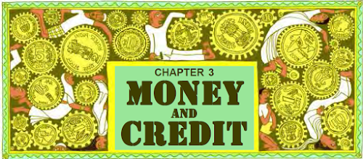
GIST

KEY CONCEPT
- Money is a fascinating subject and full of curiosities.
- The history of money and how various forms were used at different times is an interesting story.
- Credit is a crucial element in economic life so it is important to understand this concept.

MONEY
- Money is something that can be used as a medium of exchange.
- Before the introduction of money, goods were exchanged for goods which was known as barter system.
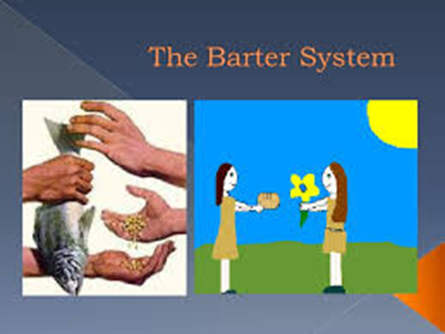
But there were many problems in the barter system which are as follows:
- Difficulty in calculating the value of goods.
- Double coincidence of wants is necessary condition to exchange the things.
- Problem of divisibility
- Difficulty in storing and carrying goods over time and distance.
Double coincidence of wants means both parties have to agree to sell and buy each other’s commodities. A person desires to sell exactly what the other wishes to buy.
FUNCTIONS OF MONEY
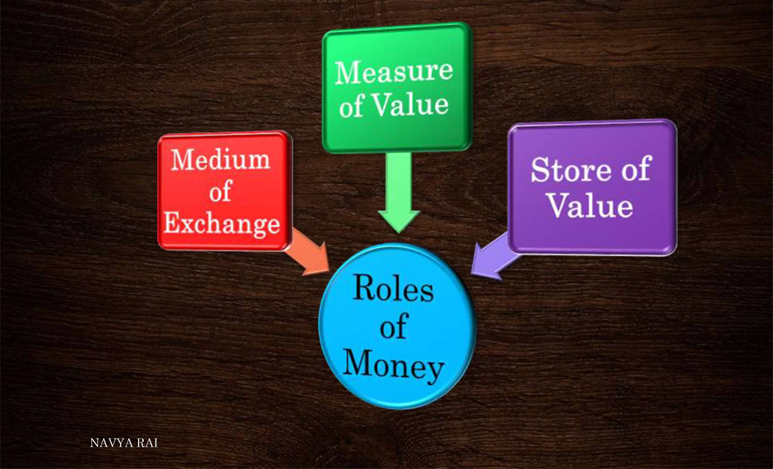
Other advantages
- It solves the problem of double coincidence of wants
- It is very easy to carry
- There divisibility in the money.

FORMS OF MONEY
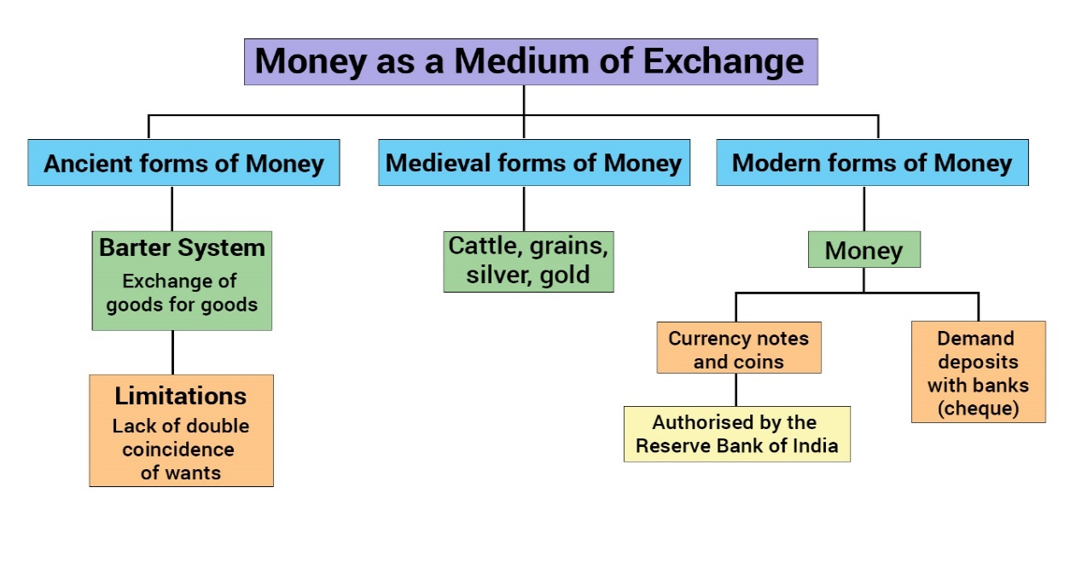

MONEY AS A MEDIUM OF EXCHANGE
- Money accepted as a medium of exchange because the currency is authorised by the government of the country.
- In India, the Reserve Bank of India issues currency notes on behalf of the central government.
- As per Indian law, no other individual or organisation is allowed to issue currency.
- Moreover, the law legalizes the use of rupee as a medium of payment that cannot be refused in settling transactions in India.
- No individual in India can legally refuse a payment made in rupees. Hence, the rupee is widely accepted as a medium of exchange.

DEPOSITS WITH BANKS
- The other form in which people hold money is as deposits with banks.
- Banks accept the deposits and also pay an amount as interest on the deposits. In this way people’s money is safe.
- People also have the provision to withdraw the money as and when they require.
- Since the deposits in the bank accounts can be withdrawn, these deposits are called demand deposits.
CHEQUE:
A cheque is a paper instructing the bank to pay a specific amount from the person’s account to the person in whose name the cheque has been issued.

FUNCTIONS OF BANKS
- The persons who have excess money can deposit their money in the banks.
- Banks keep only a small proportion of their deposits as cash with themselves.
- In India banks hold about 15 per cent of their deposits as cash(CRR).
- This is kept as provision to pay the depositors who might come to withdraw money from the bank on any given day.
- Banks use the major portion of the deposits to extend loans to those persons who required money.
- There is a huge demand for loans for various economic activities.
- Banks charge a higher interest rate on loans than what they offer on deposits.
- The difference between what is charged from borrowers and what is paid to depositors is their main source of income.
FUNCTIONS OF RBI (THE RESERVE BANK OF INDIA)

CREDIT OR LOAN
- Credit (loan) refers to an agreement in which the lender supplies the borrower with money, goods or services in return for the promise of future payment.

TERMS OF CREDIT
- The condition on which the lender gives the loan to the borrower is known as terms of credit. In terms of credit these conditions are included

TERMS OF CREDIT

POSITIVE SIDE OF CREDIT
- It helps people from all walks of life in setting up their business, increase their income and provide support to their family needs.
- It makes it possible for the people to own or construct their own house and get relief from monthly rent.
- People often avail themselves of credit to purchase luxury items like vehicles, ACs, etc., which further raises their standard of living.
- It enables us to invest in human resource. People take credit for education, training, etc. which allows enrichment of human resource.
- For example, Salim availed credit facility to meet the working capital needs of production. It helped him to meet the ongoing expenses of production, complete production on time, thereby, increasing his income.
CREDIT - NEGATIVE SIDE
- Credit in some case pushes the borrower into a situation from which recovery is very painful.
- The borrower will be caught in debt trap.
- Sapna, a small farmer, grows groundnut in her three acres of land. She took a loan from the moneylender, hoping to repay the loan, once the crop is harvested. Being hit by the pest, the crop fails. Expensive pesticides did not make any difference. Sapna is unable to repay the moneylender and the other year, it becomes a bigger amount. Next year again, she took a loan for cultivation. It is not a bumper crop this year too. Sapna earns little, but it is not enough to repay the old loans. She had to sell a part of the land to repay the loan. She is caught in a debt. This situation is called debt-trap.
DIFFERENT SOURCES OF CREDIT
- The various types of loans can be conveniently grouped as formal sector loans and informal sector loans.
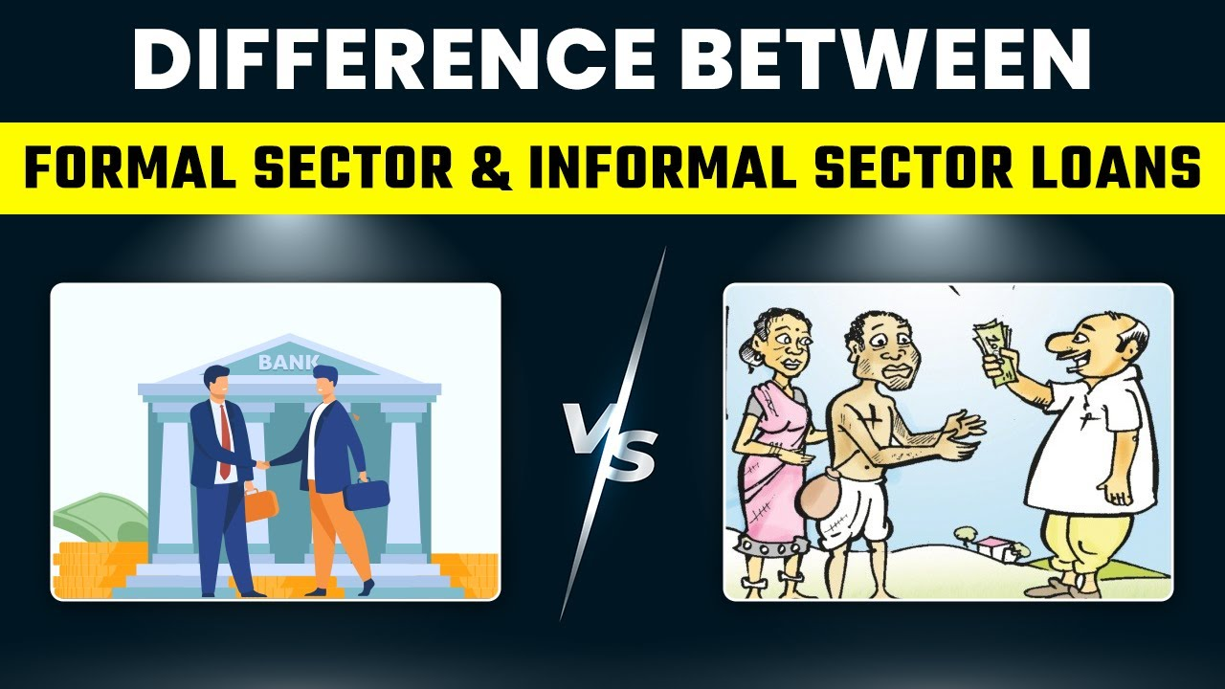

FORMAL SOURCE OF CREDIT | INFORMAL SOURCE OF CREDIT
These sources of credit supervise by RBI. | These sources of credit are not supervised by any government agency.
2. The rate of interest is low. | 2. Here the rate of interest is high.
3. For these sources of credit collateral is compulsory. | 3. For these sources of credit collateral is not compulsory.
4. Most of Rich, business class and middle class use these sources of credit to take loan. | 4. Most of poor persons like peasant, farmers and labours use these sources of credit to take loan.
5. It included the loan taken from banks and cooperatives. | 5. It included the loan taken from landowners, friends, relatives etc.

SOURCES OF CREDIT

InFormal sources of credit

Formal sources of credit

- Supervise by RBI.
- Low interest rate
- Collateral is compulsory.
- Loan taken from banks and cooperatives
- Rich, business class and middle class use these
- Not supervised by any government agency.
- High interest rate .
- Collateral is not compulsory.
- Peasant, farmers and labours use these
- loan taken from landowners, friends, relatives

IMPORTANCE OF CHEAP AND AFFORDABLE CREDIT
Cheap and affordable credit is crucial for the country’s development because: -
- More lending would lead to higher incomes and encourage people to invest in agriculture, engage in business and set up small industries.
- Cheap credit will enable more investment. This leads to acceleration of economic activity.
- Cheap credit would also allow weaker sections of society to access formal sector of lending and get rid of from informal moneylenders.
- Affordable credit would also end the cycle of debt trap.
- Cheap and easy terms of credit would inspire better investment in technology and thus increase competition.
SELF-HELP GROUPS

A group of 15 to 20 poor villagers, especially women, who regularly pool money at regular intervals to meet the requirement of money in future at very low interest rate, is known as SHG.

Advantages of SHG’S

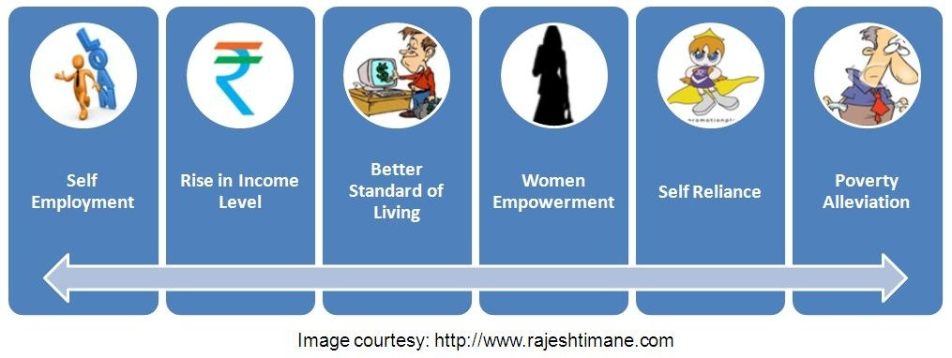

IMPORTANCES OF SHGS
- Self-Help Groups are emerging as an important source of credit because:
- The members can take loans from the groups to meet their daily needs.
- All decisions regarding savings and loans are taken by the members of the group.
- They charge less interest on the loans than what the moneylenders charge.
- If the group is regular in its savings, they can also take loan from the bank. Loan is sanctioned in the name of the group. The group is responsible for the repayment of loan
- They help borrowers to overcome the problem of collateral.
- They have freed borrowers from the clutches of the moneylenders.
- Not only does it help women to become financially self-reliant, the regular meetings of the group provide a platform to discuss and act on a variety of social issues such as health, nutrition, domestic violence, etc.
MULTIPLE CHOICE QUESTIONS

1. | Which of the following is not true regarding the in convenience of Barter Exchange?  (a) Lack of double coincidence of want  (b) Absence of divisibility  (c) Difficulty in storing wealth  (d) Availability of money as a medium of exchange. Answer: (d) Availability of money as a medium of exchange
2. | Which one of the following is not a modern form of money?  (a) Demand Deposits  (b) Paper currency  (c) Coins  (d) Precious metal Answer: (d) Precious metals
3 | Which one of the following is the important characteristic of modern form of currency?  (a) It is made from precious metal  (b) It is made from thing of everyday use  (c) It is authorised by the commercial banks  (d) It is authorised by the Government of the country  Answer: (d) It is authorised by the Government of the country
4. | Formal Sources of credit include:  (a) money lenders  (b) co-operatives  (c) Employers  (d) Finance companies Answer: (b) co-operatives.
5. | Which one of the following is NOT an informal sector loans for poor rural household in India?  (a) Commercial Banks  (b) Moneylenders  (c) Traders  (d) Landlords Answer: (a) Commercial Banks
6. | In a SHG most of the decisions regarding loan activities are taken by  (a) Banks  (b) Members  (c) Non-government organizations  (d) Cooperatives Answer: (b) Members
7. | Banks do not give loans:  (a) to small farmers  (b) to marginal farmers  (c) to industries  (d) without proper collateral and documents  Answer: (d) without proper collateral and documents
8. | Which one of the following agencies issues currency notes on behalf of the government of India?  (a) Ministry of Finance  (b) Reserve Bank of India  (c) State Bank of India  (d) World Bank  Answer: (c) State Bank of India
9. | Which one of the following is the important characteristic of modern form of currency?  (a) It is made from precious metal  (b) It is made from thing of everyday use  (c) It is authorised by the commercial banks  (d) It is authorised by the Government of the country  Answer: (d) It is authorised by the Government of the country
10. | Which one of the following is the main source of credit for the rich households?  (a) Informal  (b) Formal  (c) Both formal and informal  (d) Neither Formal nor informal Answer: (b) Formal
11. | Which one of the following is not included in the terms of credit?  (a) Rate of Interest  (b) Mode of payment  (c) Rate of saving  (d) Collateral Answer: (c) Rate of saving
12. | What portion of deposits are kept by the banks for their day to day transaction?  (a) 10%  (b) 15%  (c) 20%  (d) 25% Answer: (b) 15%
13 | Banks use the major portion of the deposit to:  (a) Keep reserve so that people may withdraw  (b) Meet their routine expenses  (c) Extend loans  (d) Meet renovation of the bank Answer: (c) Extend loans
14. | Terms of credit are with respect to:  (a) interest rate  (b) collateral  (c) documentation  (d) all the above Answer: (d) all the above
15. | At present which form of money is increasingly used apart from paper money?  (a) Commodity money  (b) Metallic money  (c) Plastic money  (d) All the above  Answer: (c) Plastic money
16. | Which state accounts for maximum percentage of SHGs (self-help groups) in bank credit?  (a) Andhra Pradesh  (b) Tamil Nadu  (c) Kerala  (d) Karnataka Answer: (a) Andhra Pradesh
17. | Who supervises the credit activities of lenders in the informal sector?  (a) Central Bank of India  (b) Commercial banks  (c) Moneylenders  (d) None  Answer: (d) None
18. | Which of the following is not a source of rural credit?  (a) Regional rural banks  (b) Moneylenders  (c) Traders  (d) Government Answer: (d) Government
19. | Which state accounts for maximum percentage of SHGs (self-help groups) in bank credit?  (a) Andhra Pradesh  (b) Tamil Nadu  (c) Kerala  (d) Karnataka Answer: (a) Andhra Pradesh
20. | Regional Rural Banks were set up in ________.  (a) 1969  (b) 1979  (c) 1989  (d) 1999 Answer: (a) 1969
21. | Rate of interest charged by moneylenders as compared to that charged by banks is:  (a) lower  (b) same  (c) slightly higher  (d) much higher Answer: (d) much higher
22. | Who supervises the functioning of formal sources of loans?  (a) Reserve Bank of India  (b) Central government  (c) State government  (d) None  Answer: (a) Reserve Bank of India
23. | Formal sources of credit include  (a) banks  (b) moneylenders  (c) employers  (d) all the above  Answer: (a) banks
24. | Which of the following is a major reason which prevents the poor from getting bank loans?  (a) Absence of collateral (security)  (b) Non-repayment of loans  (c) Higher interest rates  (d) Documentation  Answer: (a) Absence of collateral (security)
25. | Who helps the borrowers to overcome the problem of lack of collateral?  (a) Self-help group (SHG)  (b) State government  (c) Employers  (d) Moneylenders  Answer: (a) Self-help group (SHG)
26. | Which of the following is not an advantage of self-help group?  (a) Grant of timely loans  (b) Reasonable interests  (c) A platform to discuss various issues  (d) Does not help women to become self-reliant.  Answer: (d) Does not help women to become self-reliant.
27 | Fill in the Blanks
1. …………. implies the direct exchange of goods against goods without the use of money.
2. …………. may be defined as anything which is generally accepted by people in exchange of goods and services or in repayment of debts.
3. In India, the law legalises the use of …………. as a medium of payment that cannot be refused in settling any transaction.
4. Money as a medium of exchange has removed the problem of …………. of wants.
5. Modern forms of money include currencies which are …………. and ………….
6. …………. help in pooling the savings of their members, who are poor women to meet their credit needs.
7. The share of formal sector credit is …………. for the richer households as compared to the poor households in India.
8. Absence of …………. as a guarantee is a major cause that prevents poor people from obtaining loans from formal sector sources, such as commercial banks.
Answers
1.Barter system
2. Money
3. rupee
4. double coincidence
5. paper notes, coins
6. Self Help Groups
7. higher
8. Collateral
28 | What kind of transaction does this picture show?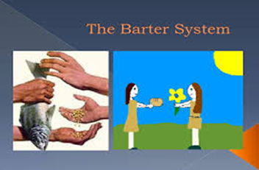
29 | What does this picture depict? Give one word that explains all that is shown in the picture which is an essential part in the formal source of credit.
30 | Given below are two pictures of credit transaction. Name it?
 | 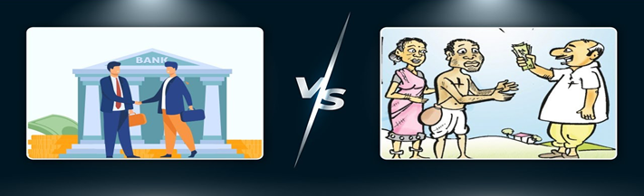
Directions: - In the following questions, the
Assertions (A) and Reason(s) (R) have been put forward. Read both statements carefully and choose the correct answer from the below:
(a) Both assertion and reason are true, and reason is the correct explanation of assertion.
(b) Both assertion and reason are true, but reason is not the correct explanationof assertion.
(c) Assertion is true, but reason is false.
(d) Both assertion and reason are false.
31 | Assertion (A): Collateral is an asset that the borrower owns (such as land, building, vehicle, livestock, deposits with banks) and uses this as a guarantee to a lender until the loan is repaid.  Reason (R): Collateral is given as the lender can sell the collateral to recover the loan  amount if the borrower fails to repay the loan.  Answer – (a) Both assertion and reason are true, and reason is the correct explanation of assertion.
32 | Assertion (A): Banks charge a higher interest rate on loans than what they offer on deposits.  Reason (R): The difference between what is charged from borrowers and what is paid to  depositors is their main source of income.  Answer – (a) Both assertion and reason are true, and reason is the correct explanation of assertion.
33 | Assertion (A): Credit would be useful or not depends on the risk involved in a situation.  Reason (R): The chance of benefitting from credit ishighest in agriculture sector.  Answer – (c) Assertion is true, but reason is false.
34 | 4.) Assertion (A): Banks keep only a small proportion of their deposits as cash with themselves.  Reason (R): Banks in India these days hold about 15 per cent of their deposits as cash.  Answer – (b) Both assertion and reason are true, but reason is not the correct explanation of assertion.
35 | Assertion (A): The terms of deposit are same for all credit arrangements.\  Reason (R): Credit arrangements are very complex process so to remove the complexities same terms of deposits are used  Answer – (d) Both assertion and reason are false
36 | Assertion (A): The facility of demand deposits makes it possible to settle payments without the use of cash.  Reason (R) : Demand deposits are paper orders which make it  possible to transfer money from one person’s account to another person’s account.  Answer – (d) Both assertion and reason are false.
37 | Assertion (A): The Reserve Bank of India supervises the functioning of formal sources of loans.  Reason (R): The RBI sees that the banks give loans not just to profit-making businesses and traders but also to small cultivators, small scale industries, to small borrowers etc.  Answer – (b) Both assertion and reason are true, but reason is not the correct explanation of assertion.
38 | Assertion (A): In India, no individual can refuse to accepta payment made in rupees.  Reason (R): Rupee is the legal tender in India  Answer – (a) Both assertion and reason are true, and reason is the correct explanation of assertion.
39 | Assertion (A): Sohan took credit in the form of advance payment from a buyer and he delivered the goods to the buyer on time and also earned profit. The credit made sohan better off in this situation.  Reason (R): Credit can never push a person into a debt trap.  Answer – (c) Assertion is true, but reason is false.
40 | Assertion (A): The modern currency is used as a medium of exchange; however, it does not have a use of its own.  Reason (R): Modern currency is easy to carry  Answer – (b) Both assertion and reason are true, but reason is not the correct explanation of assertion.
 | VERY SHORT ANSWER ( 2 MARKS)
1 | How is money beneficial in transactions?  Answer: Money is beneficial in transactions. It eliminates the need for double coincidence of wants. It acts as a medium of exchange.
2 | How does the use of money make it easier to exchange things? Give an example.  Answer: A person holding money can easily exchange it for any commodity or service that he or she might want.  Example: The shoe manufacturer will first exchange shoes that he has produced for money and then exchange the money for wheat.
3 | Why one cannot refuse a payment made in rupees in India?  Answer: One cannot refuse a payment made in rupees in India: Because it is accepted as a medium of exchange. The currency is authorized by the government of the country.
4 | What does modern form of money include?  Answer: Modern form of money includes currency—that is paper notes and coins.
5. | Does modern currency have any use of its own?  Answer: Unlike the things that were used as money earlier, modern currency is not made of precious metal such as gold, silver and copper. And unlike grain and cattle, they are neither of everyday use. The modern currency is without any use of its own.
6. | What are ‘demand deposits’?  Answer: People deposit their money in the bank as it earns interest. Since the deposits in the bank accounts can be withdrawn on demand, these deposits are called demand deposits.
7. | What is a ‘cheque’?  Answer: A cheque is a paper, instructing the bank to pay a specific amount from the person’s account to the person on whose name the cheque has been issued.
8. | What is the main source of income of the banks?  - Answer: Banks charge a higher rate of interest on loans than what they offer on deposits.  - The difference between what is charged from borrowers and what is paid to depositors is their main source of income.
9. | What is ‘credit’?  Answer: Credit (loan) refers to an agreement in which the lender supplies the borrowers with money, goods or services in return for the promise of future payment.
10.. | What is a ‘debt trap’?  Answer: A debt trap means the inability to repay the credit amount. It is a situation where the debtor or borrower could not be able to repay the amount borrowed .
11 | Why are most of the poor households deprived from the formal sector of loans? [  - Answer: Most of the poor households are deprived from the formal sector of loans because of:  - Lack of collateral. They are illiterate and Cannot fulfill the formalities of the formal sector of loans.
12. | Prove with an argument that there is a great need to expand formal sources of credit in rural India.  Answer: To expand formal sources of credit in rural India, dependence on informal sources of credit has to be reduced.
13 | Amit is using his money to buy assets like house, commercial land and machines. Write what is he actually doing?  Answer: He is investing his money with a hope of earning profits from these assets.
 | SHORT ANSWER QUESTIONS (3MARKS)
1. | Give an example to show that double coincidence of wants is necessary in a barter system.  - A shoe manufacturer wants to sell shoes in the market and buy wheat.  - The shoe manufacturer will first exchange shoes that he had produced for money, and then exchange the money for wheat. Imagine  - It would be difficult if the shoe manufacturer had to directly exchange shoes for wheat without using money.  - He would have to look for a wheat growing farmer, who not only wants to sell wheat but also wants to buy the shoes in exchange.  - That is, both parties have to agree to sell and buy each other’s commodities. This is known as double coincidence of wants.
2. | How is modern form of currency accepted as a medium of exchange? Or  Why is currency accepted as a medium of exchange?  - Modern forms of money include currency paper notes and coins.  - Modern currency is not made of precious metals such as gold, silver and copper.  - The modern currency is without any use of its own. In India, Reserve Bank of India issues currency notes on behalf of the Central government.  - As per the Indian law, no other individual or organisation is allowed to issue currency.  - No individual in India can legally refuse a payment made in rupees.
3. | State three disadvantages of the barter system.  - In a barter system, double coincidence of wants is required.  - Here, the person is required to sell only what the other wishes to buy.  - If both parties do not agree, the goods cannot be exchanged for goods. money.  - The facility of Cheques against demand deposits makes settlement of payments possible without using cash.  - Since demand deposits are accepted widely as a means of payment, along with currency, they constitute money in the modern economy.
4. | What are ‘demand deposits’?  Answer:  - Workers who receive their salaries at the end of each month have extra cash at the beginning of the month.  - This extra cash is deposited with the bank by opening a bank account in their name.  - Banks accept the deposits and also pay an interest rate on the deposits.  - In this way, people’s money is safe with the banks and it earns an interest as well.  - People also have the provision to withdraw the money as and when they require.  - Since the deposits in the bank accounts can be withdrawn on demand, these deposits are called demand deposits.
5. | How are demand deposits accepted as a means of payment?  - Demand deposits offer another interesting facility. It helps in making the payment in cheque.  - A cheque is a paper instructing the bank to pay a specific amount from the person’s account to the other person or to the account holder.  Thus, we see that demand deposits share the essential features of
6. | Illustrate with examples the role of ‘loan’ in ‘businesses’. Answer: Role of Loan  - Loan is a crucial element in economic life and plays a vital and positive role.It helps to increase earnings.  - Salim obtains credit to meet the working capital needs of production. The credit helps him to meet the ongoing expenses of production, complete production on time, and thereby increase his earnings. Credit therefore plays a vital and positive role in this situation.  - It makes a person economically better off than before It helps the poor and needy at the time of crisis.  - It helps the person to meet the ongoing expenses of production and complete production on time.  - In another situation, because of the crop failure, loan pushes the person into a debt trap.Examples of Salim and Laksmi could be given.
7. | Why does the formal or informal sector asks for a collateral?  - Every loan agreement specifies an interest rate which the borrower must pay to the lender along with the repayment of the principal.  - In addition, lenders may demand a collateral or an asset that the borrower owns to use it as a guarantee until he repays the loan.  - Interest rate, collateral and documentation requirement and the mode of repayment are the terms of credit required for formal or informal sectors for loans
8. | How are cooperatives functioning in the rural areas to solve the problem of credit?  - Besides banks, the other major source of cheap credit in rural areas are the cooperatives.  - Members of a cooperative, pool their resources for cooperation in certain areas.Cooperatives form members, who accept deposits from its members.  - With these deposits as collateral, the cooperative obtains a large loan from the bank. These funds are used to provide loans to members. Once these loans are repaid, another round of lending can take place.
9. | Identify transactions involving money in our day-to-day life.  - There are several transactions involving money in any single day. In many of these transactions, goods are being bought and sold with the use of money.  - It eliminates the need for double coincidence of wants.In some of these transactions, services are being exchanged with money.  - For some, there might not be any actual transfer of money taking place now but a promise to pay money later.
10 | Why are transactions made in money?  - A person holding money can easily exchange it for any commodity or service that he or she might want.  - Thus, everyone prefers to receive payments in money and then exchange the money for things that they want.  - Take the case of a shoe manufacturer. He wants to sell shoe in the market and buy wheat. The shoe manufacturer will first exchange shoe that he has produced for money and then exchange the money for wheat.
11. | State any three advantages of an ATM.  - All Time Money is a provision called the Automated Teller Machine. In case of an ATM, direct interaction with the bank is not required.  - Money can be withdrawn from the ATM during the entire twenty-four hours in a day, whereas banks close their public dealings at a particular time, binding the depositor to come within that stipulated period. Banks are efficient medium of exchange:  - Demand deposits share the essential features of money.  - Hence Demand Deposit is considered modern form of money.  - The facility of cheque against demand deposit makes it possible to directly settle payment without the use of cash.  - Demand deposits are accepted widely as a means of payment
12 | Explain any three loan activities of banks in India.  Loan activities of Banks in India:  - Banks use the major portion of the deposits to extend loans. Banks make use of the deposits to meet the loan requirements of the people.  - Banks mediate between those who have surplus funds (the depositors) and those who are in need of these funds (the borrowers). Banks charge a higher interest rate on loans than what it offers on deposits.
13 | Which objects were used as money?  - Before the introduction of coins, a variety of objects were used as money.  - For example, since the very early ages, Indians used grains and cattle as money. cowri shells were also used as money.  - Thereafter, came the use of metallic coins a phase which continued well into the last century.
14. | How do farmers get into debt trap?  - Farmers usually take crop loans at the beginning of the season and repay the loan after harvest. Sometimes, the failure of the crop makes loan repayment impossible.  - So, the farmers have to sell a part of their land to repay the loan.  - Credit in such a condition pushes the borrowers into a situation from which recovery is painful and they get into the debt trap.
15 | Self-help Groups support has brought about a revolutionary change in the rural sector.  - The idea is to organize rural poor, in particular women, into small Self Help Groups (SHGs) and pool their savings. Members can take small loans from the group itself to meet their needs. The group charges interest on these loans but this is still less than what the moneylender charges.  - If the group is regular in savings, it becomes eligible for availing loan from the bank. Loan is sanctioned in the name of the group and is meant to create self – employment opportunities for the members. The SHG is responsible for repayment of the loan, hence, banks get ready to give loans without collateral.  - Self-help, self-reliance and creating a support system and platform to discuss and act on a variety of social issues such as health, nutrition, domestic violence etc.
16. | Why do we need to expand formal sources of credit in India? Give three reasons.  - The cost of informal loans is much higher and often leads to a debt trap. Also, people who might wish to start a new enterprise by borrowing may not do so because of the high cost of borrowing in such a case.  - Most loans from informal lenders carry a very high interest rate and do little to increase the income of the borrowers. Thus, it is necessary that banks and cooperatives increase their lending particularly in the rural areas, so that the dependence of the poor on informal sources of credit reduces.  - It is important that the formal credit is distributed more equally so that the poor can benefit from the cheaper loans.
17. | Dhananjay is a government employee and belongs to a rich household whereas Raju is a construction worker and comes from a poor rural household. Both are in need and wish to take loan. Create a list of arguments explaining who between the two would successfully be able to arrange money from a formal source. Why?  Answer: Dhananjay will be able to get loan from a formal source.  Arguments: Banks are not present everywhere in rural India. Even when they are present, getting a loan from a bank is much more difficult than taking a loan from informal sources. Bank loans require proper documents and collateral. Absence of collateral is one of the major reasons which prevents the poor from getting bank loans. Informal lenders such as moneylenders, on the other hand, know the borrowers personally and hence are often willing to give a loan without collateral.
18. | Explain the values which a borrower should observe for the proper use of loan taken.  - Borrower should observe the following for the proper use of loan taken:  - Proper planning of both for borrowing and spending of loan amount.Use the loan for the purpose for which it has been borrowed.  - Follow the terms and conditions of the credit. To develop consciousness to repay the loan on time.
19. | “Deposits with the banks are beneficial to the depositers as well as to the nation”. Examine the statement. Answer: Deposits with the banks are beneficial to the depositors as well as to the nation.  Benefits to the Depositors  (i) Banks accepts the deposits and pay interest to the depositor.  (ii) People’s money is safe with the banks.  (iii) People can withdraw the money as and when they require.  Benefits to the Nation  (i) Banks use money of the depositor to afford loans.  (ii) There is a huge demand for loans for various economic activities.  (iii) Banks mediate between those who have surplus funds and those who are in need of these funds. Thus it helps in the economic development of the nation.
20. | Credit has its own unique role for development’. Justify the statement with arguments. OR  Describe the vital and positive role of credit. Answer: “Credit has its own unique role for development”  (i) Credit helps to increase earning and therefore the person is better off than before. For example, as in (Salim’s case)  (ii) Credit helps to earn money as well as capital for the future.  (iii) Credit helps in the development of infrastructure of the society that leads to the overall development.
21. | How is money transferred from one bank account to another  bank account? Explain with an example.  Answer: Money Transfer from one bank account to another bank account. If a person has to make a payment to his or her friend and writes a cheque for a specific amount, this means that the person instructs his bank to pay this amount to his friend. His friend takes this cheque and deposit in his account in the bank. This said amount is transferred from one bank account to another bank account Money Transfer from one bank account to another bank account. If a person has to make a payment to his or her friend and writes a cheque for a specific amount, this means that the person instructs his bank to pay this amount to his friend. His friend takes this cheque and deposit in his account in the bank. This said amount is transferred from one bank account to another bank account.
22. | How is the concept of Self Help Groups important for poor people? Give your view point  Answer:  (i) Self Help Groups help in pooling the savings of the members, who are poor people.  (ii) Members can get timely loans for a variety of purposes.  (iii) They get loan at a reasonable rate of interest.  (iv) It helps borrowers to overcome the problem of lack of collateral and documentation.  (v) It saves them from exploitation of the money lenders.  (vi) This interest income becomes an extra source of income of the members
 | LONG ANSWER TYPE QUESTIONS (5 MARKS
1. | Review any three merits and any two demerits of ‘formal sector of credit’ in India.  Answer: Merits  (i) Helps to meet the working capital needs of production.  (ii) Helps in ongoing expenses of production.  (iii) Helps in completing production on time.  (iv) Helps in increasing earnings.  (v) Low interest rates.  (vi) Easy access of loans to small cultivators and small scale industries.  Demerits  (i) Difficulty in obtaining loans.:  (ii) Collateral issues.  (iii) Documentation could be a problematic issue for few.  (iv) Lack of credibility in rural areas.
2. | Why are poor households still dependent on informal sources of credit? OR  “Poor households still depend on informal sources of credit.” Support the statement with examples.  - Banks are not present everywhere in rural India.  - Even if they are present, getting a loan from a bank is much more difficult than taking a loan from informal sources.  - Bank loans require proper documents and a collateral. Absence of collateral is one of the major reasons which prevents the poor from getting bank loans.  - Informal lenders like moneylenders know the borrower personally and hence, are often willing to give a loan without a collateral.  - The borrowers can, if necessary, approach the moneylender even without repaying their earlier loans.  - However, the moneylenders charge very high rates of interest, keep no records of the transactions and harass the poor borrowers.  3. What are the advantages of SHGs?
3. | “Banks are efficient medium of exchange.” Support the statement with arguments.  Answer:
4. | What are the differences between formal and informal sources of credit?  FORMAL SOURCE OF CREDIT INFORMAL SOURCE OF CREDIT  These sources of credit supervise by RBI. These sources of credit are not supervised by any government agency.  2. The rate of interest is low. 2. Here the rate of interest is high.  3. For these sources of credit collateral is compulsory. 3. For these sources of credit collateral is not compulsory.  4. Most of Rich, business class and middle class use these sources of credit to take loan. 4. Most of poor persons like peasant, farmers and labours use these sources of credit to take loan.  5. It included the loan taken from banks and cooperatives. 5. It included the loan taken from landowners, friends, relatives etc.
5. | What is a cheque? How does it replace currency?  - A cheque is a paper instructing the bank to pay a specific amount from the person’s account to the person in whose name the cheque has been drawn.  - The facility of cheque against demand deposits makes it possible to directly settle the payments without the use of withdrawal.  - For payment through cheque, the payer who has an account with the bank, makes out a cheque of a specific amount.  - The money is transferred from one bank account to another in a couple of days. The transaction is complete without any payment of cash.
6. | What is credit? How can credit be both an asset as well as a debt trap?  - Credit refers to an agreement in which the lender supplies the borrower with money, goods or services in return for the promise of future payment.  - Example of credit as an asset: During the festival season, a shoe manufacturer has received an order of making shoes in bulk, within a month’s time. To complete production, he hired some extra workers and had to purchase the raw materials.  - He asks the supplier to supply leather now and promises to pay him later. Then he took some advance payment from the trader.  - By the end of the month, he is able to deliver the order, make a good profit and repay the money he had borrowed.  - Example of credit as debt trap: A farmer picks up the loan from a moneylender to meet the expenses of cultivation. But unfortunately the crop is hit by the pests and fails.  - So, he is unable to repay the loan and debt grows larger with interest. Next year, he picks up a fresh loan and is able to have a normal crop that year. But earnings are not enough to pay the earlier debt. So, he is caught in a debt trap. He can repay the loan, only after selling a part of the land.  - In shoemaker’s case, credit plays a vital and positive role, whereas in farmer’s case credit pushes the borrower into a situation from which recovery is very painful.
7. | What are the terms of credit?  - Every loan agreement specifies an interest rate which the borrower must pay to the lender along with repayment of the principal.  - In addition, lender may demand collateral, i.e., an asset that the borrower owns and uses this as a guarantee until the loan is repaid.  - If the borrower fails to repay the loan, the lender has the right to sell the collateral to obtain payment.  - Terms of credit comprise interest rate, collateral and documentation requirement, and the mode of repayment.  - The terms of credit vary substantially from one credit arrangement to another. They may vary depending on the nature of the lender and the borrower.
8. | “The rich households are availing cheap credit from formal lenders whereas the poor households have to pay a heavy price for borrowing.” Comment.  Answer:  - The formal sector still meets only about half of the total credit needs of the rural people.  - The remaining credit needs are met from informal sources.  - Most loans from informal lenders carry a very high interest rate and do little to increase the income of the borrowers.  - Thus, it is necessary that banks and cooperatives increase their lending particularly in the rural areas, so that the dependence on informal sources of credit reduces.  - While formal sector loans need to expand, it is also necessary that everyone receives these loans.  - At present, it is the rich households who receive formal credit whereas the poor have to depend on the informal sources.
9. | Who takes the important decisions of SHGs and why?  OR  “‘Self Help Groups’ help borrowers to overcome the problem of lack of collateral.” Examine the statement.  Answer:  - Most of the important decisions regarding the savings and loan activities are taken by the group members.  - The group decides as regards the loans to be granted—the purpose, amount, interest to be charged, repayment schedule, etc.  - It is the group which is responsible for the repayment of the loan.  - In case of default by any one member, it is followed up seriously by other members in the group.  - Because of this feature, banks are willing to lend to the poor women when organised in SHGs even though they have no collateral as such.
10. | Write a note on the success story of ‘Grameen Bank of Bangladesh’.  - Grameen Bank of Bangladesh was founded by Prof. Muhammad Yunus (a recipient of Nobel Peace Prize for the year 2006) in year 1970.  - Over the last 42 years i.e., from 1976 to 2017, the operations of the bank spread to a large area of Bangladesh.  - The bank was started with a very small project and in year 2005, it spread across 40,000 villages with 6 million borrowers in various parts of Bangladesh. Most of the borrowers of this bank are women and belong to poor sections of society.  - These poor women have started ‘self-employment’ projects by taking credit from this Grameen bank.  - This credit has positive impact on these women as they started a gainful employment, which helped them not only to repay their loan but also to earn a good living for themselves and their family.
11. | . How can the formal sector loans be made beneficial for poor farmers and workers? Suggest any five measures.  - Formal sector loans can be made beneficial for poor farmers and workers in the following ways:  - It is required to create awareness among farmers about formal sector loans. Process of providing loans should be made easier.  - It should be simple, fast and timely.  More number of Nationalised banks/cooperative banks should be based in rural sector.  - Banks and cooperatives should increase facility of providing loans so that dependence on informal sources of credit reduces.  - The benefits of loans should be extended to poor farmer andsmall scale Industries.  While forma sector loans need to expand, it is also necessary that everyone receives these loans.
 | SOURCE BASED QUESTIONS
1. | The Reserve Bank of India supervises the functioning of formal sources of loans. For instance, we have seen that the banks maintain a minimum cash balance out of the deposits they receive. The RBI monitors the banks in actually maintaining cash balance. Similarly, the RBI sees that the banks give loans not just to profit -making businesses and traders but also to small cultivators, small scale industries, to small borrowers, etc. Periodically, banks have to submit information to the RBI on how much they are lending, to whom, at what interest rate, etc. There is no organisation which supervises the credit activities of lenders in the informal sector. They can lend at whatever interest rate they choose. There is no one to stop them from using unfair means to get their money back  - Which Organisation supervises the credit activities of formal sources of credit in India?  - To whom all banks lend loans?  - To whom does the banks submit information regarding their borrowing and lending activities?  Who supervises the credit activities of lenders in the informal sector?

CHAPTER-4
GLOBALISATION AND THE INDIAN ECONOMY
PRODUCTION ACROSS COUNTRIES:
- Until the middle of the twentieth century, production was largely organized within countries.
- Colonies such as India export the raw materials and food stuff and imported finished goods.
- Trade was the main channel connecting distant countries.
- This was done before large companies called multinational corporation (MNCs) emerged on the scene.
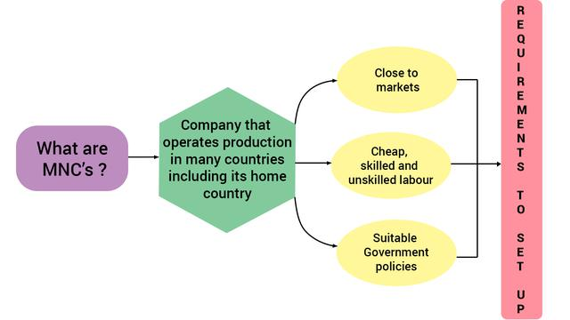

- An MNC is a company that owns or controls production in more than one nation.
- MNCs set up offices and factories for production in regions where they can get cheap labour and other resources.
- MNCs are not only selling its finished products globally but more important, the goods and services are produced globally.
- As a result, production is organized in increasingly complex ways.
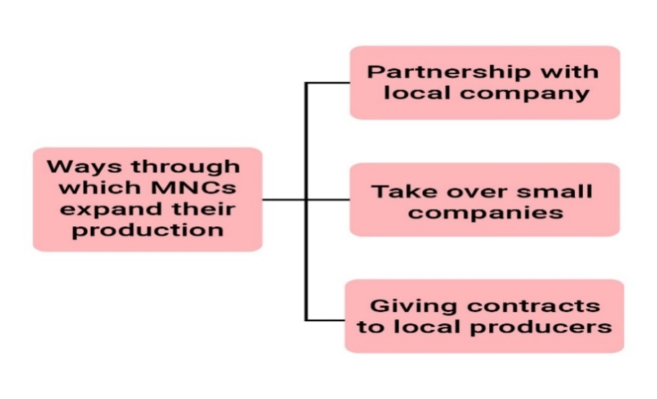

INTERLINKING PRODUCTION ACROSS COUNTRIES:

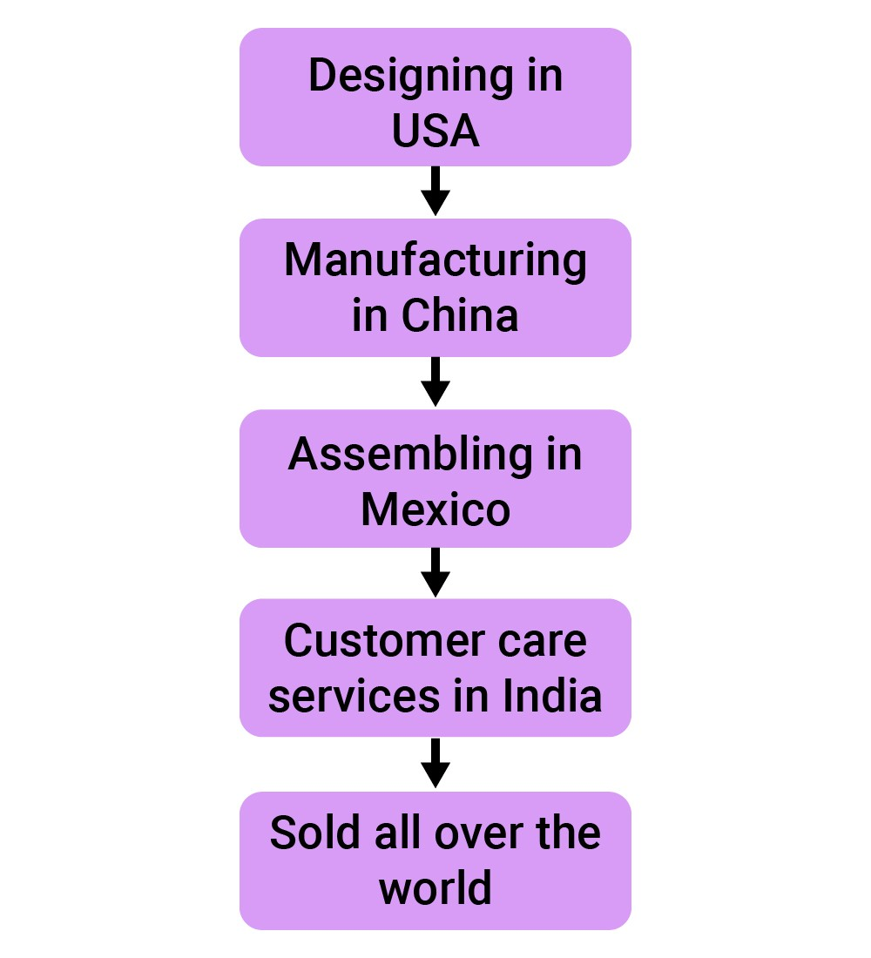
FOREIGN TRADE AND INTEGRATION OF MARKETS:
- Foreign trade creates an opportunity for the producers to reach beyond the domestic markets i.e., markets of their own countries.
- For the buyers, import of goods produced in another country is one way of expanding the choice of goods beyond what is domestically produced.
- In general, with the opening of trade, goods travel from one market to another.
- Foreign trade thus results in connecting the markets or integration of markets in different countries.
WHAT IS GLOBALISATION?

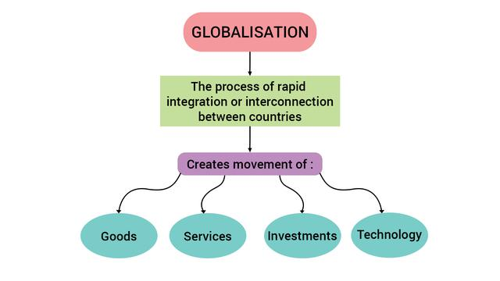
FACTORIES THAT HAVE ENABLED GLOBALISATION:

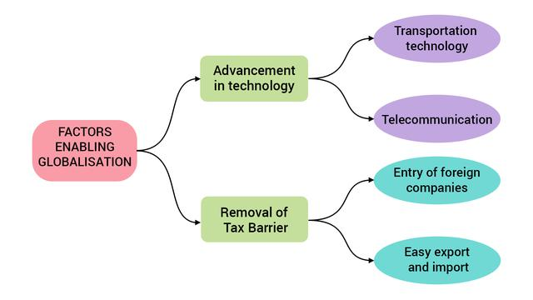
Liberalization of foreign trade and foreign investment policy:
- Tax on imports is an example of trade barrier. It is called a barrier because some restriction has been set up.
- The government can use trade barriers to increase or decrease foreign trade and to decide what kind of goods and how much of each, should come into the country.
- The Indian government, after Independence, had put barriers to foreign investment.
- This was considered necessary to protect the producers within the country from foreign competition.
- Barriers to foreign trade and foreign investment were removed to a large extent.
- This meant that goods could be imported and exported easily and also foreign companies could set up factories and offices here.
Removing barriers or restriction set by the government is what is known as liberalization.
- The government imposes much less restriction than before and is therefore said to be more liberal.

WORLD TRADE ORGANISATION:
- Liberalization of foreign trade and investment in India was supported by some very powerful international organization.
- These organizations say that all barriers to foreign trade and investment that are harmful. There should be no barriers.
- World Trade Organization (WTO) is one such organization whose aim is to liberalize international trade.
- Though WTO is supposed to allow a free trade for all, in practice, it is seen that the developed countries have unfairly retained trade barriers.
- On the other hand, WTO rules have forced the developing countries to remove the trade barriers.
IMPACT OF GLOBALISATION IN INDIA:

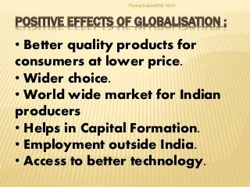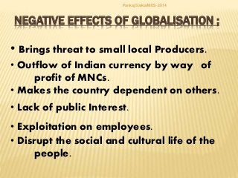

THE STRUGGLE FOR A FAIR GLOBALISATION:
- People with education skill and wealth have made the best use of new opportunities.
- On the other hand, there are many people who have not shared the benefits.
- Fair globalization would create opportunities for all and also ensure that the benefits of globalization are shared better.
- The government can play a major role in making this possible.
- Its policies must protect the interests, not only of rich and the powerful but all the people in the country.
- It can support small producers to improve their performance till the time they become strong enough to compete.
- If necessary, the government can use trade and barriers.
- In the past few years, massive campaigns and representatives by people’s organizations have influenced important decisions relating to trade and investments at the WTO.
- This has demonstrated that people also can play an important role in the struggle for fair globalization.

Q1. | What is the integration between countries through foreign trade and foreign investments by multinational corporations (MNCs)?  - International trade  B. Globalization  C. International investment  D. World trade
Q2. | ………… have been a major force in the globalization process connecting distant regions of the world?  A. Traders  B. International companies  C. Multinational corporations  D. Businesses houses
Q3, | What are the key ideas behind understanding the process of globalisation and its impact?  A. Integration of production  B. Integration of gross profits  C. Integration of markets  D. A & C
Q4. | Which factors has globalization been facilitated by?  A. Rapid improvements in technology  B. Liberalisation of trade and investment policies  C. Pressures from international organisations  D. All
Q5. | What is a multinational corporation-MNC?  A. A corporation that does international trade  B. Manufactures goods for other countries  C. A company that owns or controls production in more than one nation  D. None of the above
Q6. | MNCs set up offices and factories for production in regions where they can get…………………..?  A. Cheap labour and other resources.  B. Good market for profits  C. They can make great sales  D. More industry
Q7. | MNCs generally manufacture goods and market them……….  A. From one location in a single country  B. From different locations in a single  C. From different locations in different countries  D. All
Q8. | The money that is spent to buy assets such as land, building, machines and other equipment by MNCs is called………?  A. Investment  B. Foreign Investment  C. Domestic investment  D. International investment
Q9. | What advantage do the local companies have by setting up joint production with MNCs?  A. More profit  B. More resources  C. Latest technology for better production  D. Foreign exchange
Q10. | The most common route for MNC investments is to buy up ……………….  - Local resources  B. Local technology  C. Excess land for factories  D. Local companies  CHECK YOUR ANSWERS  1 2 3 4 5 6 7 8 9 10  B C D D C A C B C D
Q11. | In which other way do the MNCs control production?  A. By land of local country  B. Send the latest technology from parent country  C. place orders for production with small producers, which then sell these under their own brand name  D. Send the brand name to the company they buy
Q12. | Ford Motors came to India in 1995, by 2017, Ford Motors was selling …………….. cars in the Indian markets?  A. 88000  B. 85000  C. 87000  D. 84000
Q13. | Which Indian companies have invested abroad?  A. Coca Cola  B. Ranbaxy  C. Nike  D. Pepsi
Q14. | Within a year, ……….. of the toy shops had replaced Indian toys with Chinese toys?  A. 40 to 50%  BA. 50 to 60%  C. 70 to 80%  D. 80 to 90%
Q15. | Globalisation, by connecting countries, shall result in ……….?  A. lesser competition among producers.  B. greater competition among producers.  C. no change in competition among producers.  D. None of the above
Q16. | . What has been one major factor that has stimulated the globalisation process?  A. Availability of cheap labour in developing countries  B. Availability of unexploited resources in developing countries  C. Some countries are good in the landscape for natural resources  D. Rapid improvement in technology
Q17. | Goods are placed in ……….. that can be loaded intact onto ships, railways, planes and trucks?  A. Vessels  B. Containers  C. Receptacles  D. Tanks
Q18. | What is used to contact one another around the world, to access information instantly, and to communicate from remote areas?  A. Mail and telephone  B. Information technology  C. Telecommunication.  D. B & C
Q19. | Suppose the Indian government puts a tax on the import of toys from China, what would happen?  A. Toys will get cheaper, more purchase by a consumer  B. No effect  C. Toys will get expensive, less purchase by a consumer  D. Toys will get expensive, more purchase by a consumer
Q20. | Governments use …………… to increase or decrease (regulate) foreign trade and to decide what kinds of goods and how much of each, should come into the country?  - Tax levies  B. Increased taxes  C. Relaxation of taxes  D. trade barrier  CHECK YOUR ANSWERS  11 12 13 14 15 16 17 18 19 20  C A B C B D B D C D
21. Assertion and reasoning based questions:
Directions:- In the following questions, the Assertions (A) and Reason(s) (R) have been put forward. Read both statements carefully and choose the correct answer from the below:
(a)Both A and R are true, R is the correct explanation of A.
(b) Both A and R are true, But R is not the correct explanation of A.
(c) A is true , R is false.
(d) A is false , R is true
.) Assertion (A) :- Ford Motors is an MNC.
Reason (R):- It is one of the world’s largest automobile manufacturers with production spread over 26 countries.
Answer- (a) Both A and R are true, R is the correct explanation of A.
Assertion (A):- MNCs can exert a strong influence on product at distant locations
Reason (R):- MNCs set up partnership with local companies, use local companies for supplies, compete with local companies or buy them.
Answer- (a) Both A and R are true, R is the correct explanation of A.
Assertion (A) :- Online shopping has become popular among people.
Reason (R) it destroyed domestic market.
Answer- (a) Both A and R are true, R is the correct explanation of A.
Assertion (A):- Foreign trade and foreign investment are two main factors of Globalisation.
Reason (R) :-They are not playing any role in international market.
Answer- (c) A is true , R is false.
.) Assertion (A): An MNC is a company that owns or controls production in more than one nation.
Reason (R): They set up their offices and factories for production in regions where they can get cheap labour and other resources.
Answer- (a) Both A and R are true, R is the correct explanation of A.
Assertion (A):-Globalisation is related with only two countries.
Reason (R):- MNC s play major role in globalization.
Answer- (d) A is false , R is true
Assertion (A):- People are attracted towards Chinese products.
Reason (R) They are cheaper and new designed.
Answer- (a) Both A and R are true, R is the correct explanation of A.
Assertion (A):- Globalisation leads to increased competition in international and domestic market.
Reason (R):-Globalisation also makes the consumer better off as they have a wider variety of goods to choose at lower prices.
Answer- (a) Both A and R are true, R is the correct explanation of A.
Assertion (A):- Foreign trade and foreign investment are two main factors of Globalisation.
Reason (R) :-They are not playing any role in international market.
Answer- (c) A is true , R is false.
Assertion (A) :- Investment made by MNCs is called foreign investment.\
Reason (R):- They need land buildings ,machines and other equipments from that nation.
Answer- (a) Both A and R are true, R is the correct explanation of A.
Assertion (A):- Rapid improvement in technology has been one major factor that has stimulated the globalization process.
Reason (R):- Developing countries are likely to become at par with developed countries in terms of technological development due to globalization.
Answer- (a) Both A and R are true, R is the correct explanation of A.

 | VERY SHORT ANSWER QUESTIONS (2 Marks
In matter of years, how have markets been transformed ?
Answer:
The markets have been transformed because now latest models of cameras, cars,watches, mobile phones etc. are available there
What is MNC or Multi-National Corporation ?
Answer:
MNC or Multi-National Corporation is a company that owns or controls production in : more than one nation.

In which regions MNCs set up offices and factories for production ?
Answer:
Close to the market.
Availability of skilled/unskilled labour at low cost
.Favourable government policies.
What is investment and foreign investment ?
Answer:
The money that is spent to buy assets such as land, building, machines and other equipment is called investment. Investment made by MNCs is called foreign investment
What is Ford Motors ? When did it come to India and what did it do ?
Answer:
- Ford Motors, an American company, is one of the world’s largest automobile manufacturers with production spread over 26 countries of the world.
- Ford Motors came to India in 1995 and spent ?1700 crore to set up a large plant near Chennai. This was done in collaboration with Mahindra and Mahindra.

What was effect of importing Chinese toys to India ?
Answer:
Chinese toys became popular in the Indian markets.Within a year, 70 to 80 per cent shops have replaced Indian toys with Chinese toys.

What is the result of greater foreign investment and greater foreign trade ?
Answer:
Greater foreign investment and greater foreign trade leads to greater integration of production and markets across countries.

What is globalisation ?
Answer:
Globalisation is process of rapid integration or interconnection between countries. The countries are connected by movements of goods, services, investments and technology.

How information and communication technology is useful in foreign trade ?
Answer:
Telecommunication facilities – telegraph, telephone including mobile phones, fax etc. are used to contact one another around the world, to access information instantly, and to communicate from remote areas.

What is a trade barrier ?
Answer:
Restrictions on foreign trade are called trade barrier. For example tax on imports is a trade barrier.

. Why had the Indian government after independence put barriers to foreign trade and foreign
investment ?
Answer:
The Indian government put barriers to protect the producers within the country from foreign competition. Industries were just coming up and the competition from imports would not allow the Indian industries to come up.

Which Indian companies have emerged as multi-national companies as a result of globalisation? Name any two.
Answer:
Tata Motors (Automobiles)Infosys (IT)
Ranbaxy (Medicines)Asian Paints (Paints).

How many workers are employed in small-scale industries in India ?
Answer:
The small-scale industries in India employ the largest number of workers (20 million) in the country, next only to agriculture.

How have workers suffered under the flexible labour laws ? Mention any two points.
Answer:
- Workers are now employed on a temporary basis so that the employers do not have to pay workers for the whole year. ,
- Wages are low and workers are forced to work overtime to make both ends meet.
How can the globalisation be made more fair ? Write two steps and what will be its effect ?
Answer:
(1)The government must protect the interest of all the people in the country.
The government can ensure that labour laws are properly implemented and the workers get their rights.
(2) Fair globalisation would create opportunities for all, and also ensure that the benefits of globalisation are shared better.

Why had the Indian government put barriers to foreign trade and foreign investment after independence? Analyze the reasons.
Answer: The Indian government put barriers on foreign trade and foreign investment after independence because:
- It was considered necessary to protect the producers within the country from foreign competition.
- (b) In 1950s and 1960s, the industries were initial stage and competition from imports at that stage would not have allowed these industries to develop.
Therefore, India allowed the imports of only essential items like machinery, fertilizers, petroleum etc.
What changes have taken place in our markets during the last few years ?
Answer:
In the last few years, our markets have been transformed as mentioned below :
- There is a wide choice of goods and services in the markets.
- The latest models of digital cameras, mobile phones and televisions made by the leading manufacturers of the world are available in the markets. Not only this these products are affordable and within reach of the people.

 | SHORT ANSWER QUESTIONS (3 Marks)
- Explain Liberalisation and foreign trade and foreign investment policy :
- Removing barriers or restrictions set by the government is liberalisation. Under liberalisation goods can be imported and exported easily.Foreign companies are allowed to set up factories and offices in other countries.
- Thus liberalisation has enabled MNCs to increase their investments in other countries as India.As a result of greater foreign investment and greater foreign trade, there is greater integration of production and markets across countries.
- Globalisation is this process of rapid integration of interconnection between countries.
- “Globalisation and competition among producers has been of advantage to the consumers.” Give arguments in support of this statement.
Today there is more choice for the consumers in the markets. For example in the field of toys, the markets are flooded with Chinese toys which are cheaper and of better quality than Indian toys.
- People now have a choice between Indian toys and Chinese toys.
- The consumers now have products of better quality.The prices of various products have come down due to competition among the producers/manufacturers.Globalisation has led to improvement in the standard of living of people.
- What is a trade barrier ?
- “Tax on imports is one type of trade barrier. The government could also place a limit on the number of goods that can he imported. Trade barrier means restrictions to increase or decrease foreign trade and to decide what kinds of goods and how much of each should come into the country.
- Tax on imports is a trade barrier because this will lead to increase in the price of the product. In such a situation foreign products will become costlier than Indian goods and the Indian producer will be in a position to sell their products and earn profits.
- In case of Chinese toys, quotas can be used as trade barrier because the government can put restrictions on the number and type of toys that can be imported into the country. In such case, there will be less competition between Indian toys and Chinese toys. The Indian toy makers may also not suffer losses. Quotas should be used as trade barriers in the interest of the Indian toy makers.
4.Barriers on foreign trade and investment were removed to a large extent in India since 1991.” Justify the statement.
Or
Why had the Indian government put barriers to foreign trade and foreign investments after
independence ?
The Indian government had put barriers to foreign trade and foreign investment. Because this was considered necessary to protect the producers within the country from foreign competition.
The competition from well established foreign competitors would have crippled the new-bom industries of India.
All the developed countries, during the early stages of development have given protection to domestic producers through trade barrier.
LONG ANSWER QUESTIONS (5Marks)
1.Write a short note on World Trade Organisation.
World Trade Organisation was set up in 1995 at the initiative of the developed countries. Its aim is to liberalise international trade. Its headquarters is at Geneva. WTO establishes rules regarding international trade among countries of the world in an open,uniform and non-discriminatory manner. In 2006,149 countries of the world were its members.
With the liberalisation of foreign trade and investment, it is necessary to have an international organisation to supervise the trade between countries.
- It sees that all the countries in the world liberalise their policies.
- It allows free trade for all i.e., in developing and developed countries.
- It implements the rules for trade in all the countries.
- WTO looks after to make globalisation more fair to create opportunities for all and also ensure that the benefits of globalisation are shared better.

2.The impact of globalisation has not been uniform.” Discuss with the help of examples.
Or
Discuss the impact of globalisation on India. OR
Describe the effects of globalisation on small producers and workers.
Small producers such as producing batteries, capacitors, toys have been hit hard due to competition with the MNCs. They could not compete on the issue of price and quality.
As a result of it, their production decreased and many units were closed. Many workers became jobless. Many employers prefer to employ workers on temporary basis which means workers’ jobs are no longer secure.
Women are denied their fair share of benefits. Workers have to put in very long working hours without any overtime.
3. What steps have been taken by the government to attract foreign investment
The Central and the State governments are taking special steps to attract foreign companies to invest in India, Special Economic Zones are being set up.
- Special Economic Zones are to have world class facilities in the field of electricity, water, roads, transport, storage recreational and educational facilities.
- Companies which set up production units in the SEZs, do not have to pay taxes for an initial period of five years.
- Government has allowed flexibility in the labour laws. In recent years, the government has allowed companies to ignore many of rules and regulations.
- Companies can hire workers for short periods when there is intense pressure of work. This is done to reduce the cost of labour for the company.
4.Describe the steps that may be taken make globalisation more ‘fair’.
The following steps may be taken to make globalisation more fair :
- Labour laws should be implemented properly to avoid exploitation of the workers.
- The government should protect the interest of the small producers by using trade and investment barriers till they are in a position to compete with large producers or MNCs.
- The government should negotiate at the WTO for “fairer rules”.
- The government should align with other developing countries to fight against the domination of developed countries.

5.How has information and communication technology stimulated globalisation ? Explain with example.
The factors that have enabled globalisation are (a)Technology (b)Information technology :
- In the past fifty years, several improvements in technology have taken place.
- For example, in transportation technology, containers are used for the transportation of goods which are placed in containers that can be loaded intact on to ships, railways, planes and trucks. Containers have led to huge reduction in port handling costs and increased the speed with which exports can reach markets.
- Similarly, the cost of air transport has fallen. This has enabled much greater volumes of goods being transported by airlines.

Information technology :
- Telecommunication facilities – telegraph, moblie phones, fax – are used to contact one another around the world and to communicate from remote areas.This has been facilitated by satellite communication devices.
- Internet enables to send instant electronic mail and talk across the world at negligible costs.Now a news magazine published for London readers can be designed and printed in Delhi.The designing is done on a computer.
- After printing, the magazines are sent by air to London.Even the payment of money for designing and printing from a bank in London to a bank in Delhi is done instantly through the Internet e., e-banking.
6.“Globalisation and competition among producers has been of advantage to the consumers.” Give arguments in support of this statement.
- Today there is more choice for the consumers in the markets. For example in the field of toys, the markets are flooded with Chinese toys which are cheaper and of better quality than Indian toys. People now have a choice between Indian toys and Chinese toys.
- The consumers now have products of better quality.The prices of various products have come down due to competition among the producers/manufacturers. Globalisation has led to improvement in the standard of living of people.

7. What changes have taken place in our markets during the last few years ?
In the last few years, our markets have been transformed as mentioned below :
- There is a wide choice of goods and services in the markets.
- The latest models of digital cameras, mobile phones and televisions made by the leading manufacturers of the world are available in the markets. Not only this these products are affordable and within reach of the people.
Thus a few years back, there were only few brands of different goods in the markets. A consumer did not have real choice and had no option to purchase a particular brand. But now he has a number of options between Indian as well as foreign brands.

 | SOURCE BASED QUESTIONS
Ford Motors, an American company, is one of the world’s largest automobile manufacturers with production spread over 26 countries of the world. Ford Motors came to India in 1995 and spent Rs.1700 crore to set up a large plant near Chennai. This was done in collaboration with Mahindra and Mahindra, a major Indian manufacturer of jeeps and trucks. By the year 2004, Ford Motors was selling 27,000 cars in the Indian markets, while 24,000 cars were exported from India to South Africa, Mexico and Brazil. The company wants to develop Ford India as a component supplying base for its other plants across the globe.
Question 1: Would you say Ford Motors is a MNC? Why?
Answer: Ford Motors has production facilities spread over 26 countries of the world. Hence, it can be termed an MNC.
Question 2: What is foreign investment? How much did Ford Motors invest in India?
Answer: The investment which comes from abroad is called foreign investment. Ford Motors had invested Rs. 1700 crore.
Question 3: By setting up their production plants in India, MNCs such as Ford Motors tap the advantage not only of the large markets that countries such as India provide, but also the lower costs of production. Explain the statement.
Answer: The cost of labour is cheaper in India; compared to the developed countries. Thismeans that an MNC can save lot of money on wages and salaries by setting up production plants in India. This helps in lowering the cost of production. India itself is a large market with sizeable population of middle class and upper class and hence provides a big market for many products.
Question 4: Why do you think the company wants to develop India as a base for manufacturing car components for its global operations? Discuss the following factors:
(a) Cost of labour and other resources in India.

KENDRIYA VIDYALAYA SANGATHAN, CHENNAI REGION

CLASS: X | SOCIAL SCIENCE | SESSION: 2022-23
Time: 3 Hrs. |  | Maximum Marks: 80

SAMPLE QUESTION PAPER – 1 EXAMINATION BLUE PRINT
Sl.NO. | SUBJECT | TOPICS | 1-20 MCQ  (1) | 21-24 VSA (2) | 25-29 SA  (3) | 30 – 33  LA (5) | 34-36  CB(4) | 37  MAP HIS(2) GEO (3) | TOTAL MARKS  37(80)
1. | INDIA AND THE CONTEMPORARY WORLD-II | 1.THE RISE OF NATIONALISM IN EUROPE |  |  |  | 1(OR |  |  | 5
 |  | 2.NATIONALISM IN INDIA  +MAP WORK |  |  | 1 |  |  | 2 | 5
 |  | 3. MAKING OF THE GLOBAL WORLD | 1 |  |  |  |  |  | 1
 |  | 4. THE AGE OF INDUSTRIALISATION |  | 1(OR) |  |  | 1 |  | 6
 |  | 5. PRINT CULTURE | 3 |  |  |  |  |  | 3
2. | CONTEMPORARY INDIA-II | 1.RESOURCES AND DEVELPOMENT | 1 | 1 |  |  |  |  | 3
 |  | 2. FOREST AND WILD LIFE | 1 | - |  |  |  |  | 1
 |  | 3. WATER RESOURCES +MAP WORK | - | - |  |  | 1 | 1 | 5
 |  | 4. AGRICULTURE +MAP WORK | 1 | - |  |  |  |  | 1
 |  | 5. MINERAL AND ENERGY RESOURCES | - | - | 1(OR) |  |  | 1[OR] | 4
 |  | 6. MANUFACTURING INDUSTRIES | - | - |  | 1 (OR) |  |  | 5
 |  | 7. LIFE LINES OF OUR ECONOMY | - | - |  |  |  | 1 | 1
3. | DEMOCRATIC POLITICS-II | 1.POWER SHARING | 2 |  |  |  | 1 |  | 6
 |  | 2. FEDERALISM | 1 |  |  |  |  |  | 1
 |  | 3. GENDER, RELIGION CASTE | 1 | 1 |  |  |  |  | 3
 |  | 4. POLITICAL PARTIES | 1 |  |  | 1 (OR) |  |  | 6
 |  | 5. OUTCOMES OF DEMOCRACY | 1 |  | 1 |  |  |  | 4
4 | UNDERSTANDING ECONOMIC DEVELOPMENT | 1. DEVELOPMENT | 2 |  |  |  | - |  | 2
 |  | 2. SECTORS OF INDIAN ECONOMY | 2 | 1 | 1 |  | - |  | 7
 |  | 3. MONEY AND CREDIT | 1 |  |  | 1(OR) | - |  | 6
 |  | 4. GLOBALIZATION AND INDIAN ECONOMY | 2 |  | 1 |  | - |  | 5
 | TOTAL QUESTIONS (37) |  | 20(20) | 4(8) | 5(15) | 4(20) | 3(12) | 1(5) | 37(80)

MCQ- 20*1=20 MARKS
VSA- 4*2= 8MARKS
SA- 4*3=12 MARKS
L.A.-4*5=20 MARKS
C.B- 3*4=12 MARKS
MAP-2 (2+3)=5 MARKS
TOTAL- 27 QUE. 80 MARKS

SAMPLE QUESTION PAPER
SOCIAL SCIENCE (CODE 087)
CLASS X – SESSION 2022-23
Time Allowed: 3 Hours Maximum Marks: 80
सामान्य निर्देश :-
i. प्रश्न पत्र में छह खंड होते हैं - ए, बी, सी, डी, ई और एफ।प्रश्न पत्र में 37 प्रश्न हैं। सभी प्रश्न अनिवार्य हैं।
ii. खंड ए – प्रश्न 1 से 20 तक प्रत्येक 1 अंक के बहुवैकल्पिक प्रश्न हैं।
iii. खंड बी – प्रश्न संख्या। 21 से 24 अति लघु उत्तरीय प्रश्न हैं, प्रत्येक के 2 अंक हैं। प्रत्येक प्रश्न का उत्तर 40 शब्दों से अधिक नहीं होना चाहिए।
iv. खंड सी में प्रश्न 25 से प्रश्न 29 तक लघु उत्तरीय प्रश्न हैं, जिनमें से प्रत्येक में 3 अंक हैं। प्रत्येक प्रश्न का उत्तर 60 शब्दों से अधिक नहीं होना चाहिए ।
v. खंड डी – प्रश्न संख्या। 30 से 33 दीर्घ उत्तरीय प्रश्न हैं, जिनमें से प्रत्येक के लिए 5 अंक हैं। प्रत्येक प्रश्न का उत्तर 120 शब्दों से अधिक नहीं होना चाहिए।
vi. खंड-ई - प्रश्न संख्या 34 से 36 तक केस आधारित प्रश्न हैं जिनमें तीन उप प्रश्न हैं और प्रत्येक के 4 अंक हैं।
vii. खंड एफ - प्रश्न संख्या। 37 नक्शा आधारित है, जिसमें 5 अंक हैं
viii. प्रश्न पत्र में कोई समग्र विकल्प नहीं है। हालांकि, कुछ प्रश्नों में आंतरिक विकल्प प्रदान किया गया है। ऐसे प्रश्नों में से केवल एक विकल्प का प्रयास करना है।
ix. इसके अलावा, जहां आवश्यक हो, प्रत्येक अनुभाग और प्रश्न के साथ अलग-अलग निर्देश दिए गए हैं।
General Instructions :
i. Question paper comprises Six Sections – A, B, C, D, E and F. There are 37 questions in the
question paper. All questions are compulsory.
ii. Section A – From question 1 to 20 are MCQs of 1 mark each.
iii. Section B – Question no. 21 to 24 are Very Short Answer Type Questions, carrying 2 marks
each. Answer to each question should not exceed 40 words.
iv. Section C contains Q.25to Q.29 are Short Answer Type Questions, carrying 3 marks each.
Answer to each question should not exceed 60 words
v. Section D – Question no. 30 to 33 are long answer type questions, carrying 5 marks each.
Answer to each question should not exceed 120 words.
vi. Section-E - Questions no from 34 to 36 are case based questions with three sub questions
and are of 4 marks each
vii. Section F – Question no. 37 is map based, carrying 5 marks with two parts, 37a from History (2 marks) and 37b from Geography (3 marks).
viii. There is no overall choice in the question paper. However, an internal choice has been
provided in few questions. Only one of the choices in such questions have to be attempted.
ix. In addition to this, separate instructions are given with each section and question, wherever
necessary
 | SECTION AMCQs 1x20=20
1. | ब्रेटन वुड्स के तहत स्थापित विश्व संस्थानों की पहचान करें?  (ए) आईएमएफ  (बी) विश्व बैंक  (सी) आईएमएफ और विश्व बैंक  (डी) 77 . का समूह  Identify the world institutions which were established under the BRETTON WOODS ?  (a) The IMF  (b) The World Bank  (c) The IMF and The World Bank  (d) Group of 77 | 1
2. | गुलामगिरी में जाति व्यवस्था के अन्याय के बारे में किसने लिखा?  (ए) राजा राममोहन रॉय  (बी) ज्योतिबा फुले  (सी) बालगंगाधर तिलकी  (डी) बंकिम चंद्र चट्टोपाध्याय  Who wrote about the injustices of the caste system in ‘Gulamgiri’?  (a) Raja Rammohan Roy  (b) Jyotiba Phule  (c) Balgangadhar Tilak  (d) Bankim Chandra Chattopadhyay | 1
3. | चित्र का अध्ययन करें और नीचे दिए गए प्रश्न का उत्तर दें:  Study the Picture and answer the Question that follows :  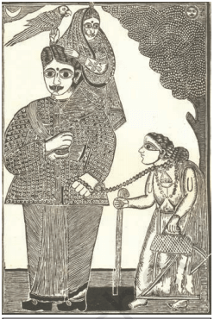  निम्नलिखित में से कौन सा पहलू 'घोर काली' की इस छवि को सबसे अच्छा दर्शाता है?  (ए) पारंपरिक पारिवारिक भूमिकाएं  (बी) पश्चिम का सांस्कृतिक प्रभाव  (सी) उचित पारिवारिक संबंधों का विनाश  (डी) इनमें से कोई नहीं  Which of the following aspect best signifies this image of ‘Ghor kali’ ?  (a) Traditional Family roles  (b) Cultural impact of the west  (c) Destruction of proper family relations  (d) None of these  नोट: निम्नलिखित प्रश्न Q.1 के स्थान पर दृष्टिबाधित उम्मीदवारों के लिए है:  प्रोटेस्टेंट सुधार के लिए कौन सा धार्मिक सुधारक जिम्मेदार था?  (ए) मार्टिन लूथर  (बी) जॉर्ज इलियट  (सी) मैक्सिम गोर्की  (डी) मार्टिन लूथर किंग  NOTE: Following question is for Visually impaired candidates in lieu of Q.1  Which religious reformer was responsible for the Protestant Reformation?  (a) Martin Luther  (b) George Elliot  (c) Maxim Gorky  (d) Martin Luther King | 1
4. | निम्नलिखित में से कौन-सी सबसे पुरानी जापानी पुस्तक है?  (ए) सुत्त पिटक  (बी) डायमंड सूत्र  (सी) महावंश:  (डी) दीपवंश  Which one of the following is the oldest Japanese book?  (a) Sutta Pitaka  (b) Diamond Sutra  (c) Mahavamsa  (d) Dipavamsa | 1
5. | निम्नलिखित को मिलाएं:  सूची 1 सूची II  1 जलोढ़ मिट्टी A राजस्थान और गुजरात  2 काली मिट्टी B ओडिशा और छत्तीसगढ़  3 लाल मिट्टी C महाराष्ट्र और मध्य प्रदेश  4 लैटेराइट मिट्टी D कर्नाटक और केरल  Match the following:  LIST 1 LIST II  1 Alluvial Soils A Rajasthan and Gujarat  2 Black Soils B Odisha and Chattisgarh  3 Red Soils C Maharashtra and Madhya Pradesh  4 Laterite Soils D Karnataka and Kerala  विकल्प / Options:  (a) 1-B,2-C,3-D,4-A  (b) 1-A,2-C,3-B,4-D  (c) 1-D,2-C,3-B,4-A  (d) 1-B,2-D,3-A,4-C | 1
6. | _______ में स्थायी वन के अंतर्गत सबसे बड़ा क्षेत्र है जो इसके कुल वन क्षेत्र का 75% है।  (ए) राजस्थान  (बी) तमिलनाडु  (सी) मध्य प्रदेश  (डी) ओडिशा  ________has the largest area under permanent forest constituting 75 % of its total forest area.  (a) Rajasthan  (b) Tamil Nadu  (c) Madhya Pradesh  (d) Odisha | 1
7. | निम्नलिखित में से कौन सी फसल आयरन, कैल्शियम और अन्य सूक्ष्म पोषक तत्वों और रौगे से भरपूर है।  (ए) बजरा  (बी) राजमा  (सी) ज्वार  (डी) रागी  Which one of the following crops is rich in iron, calcium and other micronutrients and roughage.  (a) Bajra  (b) Rajma  (c) Jowar  (d) Ragi | 1
8. | बेल्जियम में सामान्यतः कौन सी दो भाषाएँ बोली जाती हैं?  (ए) फ्रेंच और अंग्रेजी  (बी) डच और सिंहली  (सी) फ्रेंच और सिंहली  (डी) डच और फ्रेंच  Which two languages are generally spoken in Belgium?  (a) French and English  (b) Dutch and Sinhala  (c) French and Sinhala  (d) Dutch and French | 1
9 | 'चेक एंड बैलेंस' की एक प्रणाली दूसरा नाम है जिसके लिए निम्नलिखित में से एक शक्ति-साझाकरण व्यवस्था है:  (ए) विभिन्न सामाजिक समूहों के बीच सत्ता का बंटवारा।  (बी) सरकार के विभिन्न स्तरों के बीच साझा शक्ति या शक्ति का लंबवत विभाजन।  (सी) सरकार के विभिन्न अंगों के बीच साझा सत्ता या शक्ति का क्षैतिज विभाजन।  (डी) राजनीतिक दलों, दबाव समूहों और सरकारों के रूप में सत्ता का बंटवारा।  A system of ‘checks and balances’ is another name for which one of the following power-sharing arrangements:  (a) Power sharing among different social groups.  (b) Vertical division of power or power shared among different levels of government.  (c) Horizontal division of power or power shared among different organs of the government.  (d) Power sharing in the form of political parties, pressure groups and governments. | 1
10. | संविधान के अनुसार भारत के __________ में महिलाओं के लिए सीटें आरक्षित हैं।  (ए) लोकसभा  (बी) पंचायत राज निकाय  (ए) विधान सभाएं  (और) अलमारियाँ  As per Constitution seats are reserved for women in __________ of India.  (a) Lok sabha  (b) Panchayat raj bodies  (c) Legislative Assemblies  (d) Cabinets | 1
11 | निम्नलिखित में से कौन सा संघ सूची का विषय है  (ए) रक्षा  (बी) शिक्षा  (सी) व्यापार  (डी) कृषि  Which of the following is a subject of Union List  (a) Defence  (b) Education  (c) Trade  (d) Agriculture | 1
12. | राजनीतिक दलों को ……… द्वारा चिन्ह आवंटित किए जाते हैं?  (ए) भारत सरकार  (बी) भारत का संविधान  (सी) पार्टी के नेताओं  (डी) चुनाव आयोग  Political parties are allotted symbols by………?  (a) The Government of India  (b) The Constitution of India  (c) The party leaders  (d) The Election Commission | 1
13. | लोकतंत्रों के संदर्भ में, निम्नलिखित में से कौन सा विचार सही है - लोकतंत्रों ने सफलतापूर्वक समाप्त कर दिया है?  (ए) लोगों के बीच संघर्ष  (बी) लोगों के बीच आर्थिक असमानता  (सी) राजनीतिक असमानता का विचार  (डी) हाशिए के वर्गों के साथ कैसे व्यवहार किया जाए, इस बारे में मतभेद  In the context of democracies, which of the following ideas is correct – democracies have successfully eliminated?  (a) conflicts among people  (b) economic inequalities among people  (c) the idea of political inequality  (d) differences of opinion about how marginalized sections are to be treated | 1
14. | देश की कुल आय को उसकी कुल जनसंख्या से भाग देने पर __________ कहा जाता है  (ए) सकल आय  (बी) शुद्ध आय  (सी) प्रति व्यक्ति आय  (डी) कुल आय  Total income of the country divided by its total population is known as __________  (a) Gross income  (b) Net income  (c) Per capita income  (d) Total income | 1
15. | मानव विकास के मामले में निम्नलिखित में से किस पड़ोसी देश का प्रदर्शन भारत से बेहतर है?  (ए) बांग्लादेश  (बी) श्रीलंका  (सी) नेपाल  (डी) पाकिस्तान  Which of the following neighbouring countries has better performance in terms of human development than India?  (a) Bangladesh  (b) Sri Lanka  (c) Nepal  (d) Pakistan | 1
16. | __________ क्षेत्र में ऐसी गतिविधियाँ शामिल हैं जिनमें प्राकृतिक उत्पादों को विनिर्माण के तरीकों के माध्यम से अन्य रूपों में बदल दिया जाता है जिन्हें हम औद्योगिक गतिविधि से जोड़ते हैं।  (ए) माध्यमिक क्षेत्र  (बी) तृतीयक क्षेत्र  (सी) प्राथमिक क्षेत्र  (डी) उपरोक्त में से कोई नहीं  The ___________ sector involves activities in which natural products are changed into other forms through ways of manufacturing that we associate with industrial activity.  (a) secondary sector  (b) tertiary sector  (c) primary sector  (d) none of the above | 1
17. | एक विशेष वर्ष के दौरान प्रत्येक क्षेत्र में उत्पादित अंतिम वस्तुओं और सेवाओं का मूल्य _________ प्रदान करता है।  (ए) जीएनपी  (बी) जीडीपी  (सी) मुद्रास्फीति दर  (डी) औद्योगिक उत्पादन  The value of final goods and services produced in each sector during a particular year provides the ____________.  (a) GNP  (b) GDP  (c) Inflation Rate  (d) Industrial output | 1
18. | निम्नलिखित में से कौन मुद्रा का आधुनिक रूप है?  (ए) सोना  (बी) पेपर नोट्स  (सी) कॉपर  (डी) चांदी  Which one of the following is modern form of currency ?  (a) Gold  (b) Paper notes  (c) Copper  (d) Silver | 1
19. | सरकार द्वारा निर्धारित बाधाओं या प्रतिबंधों को हटाने के रूप में जाना जाता है:  (ए) निजीकरण  (बी) वैश्वीकरण  (सी) उदारीकरण  (डी) समाजीकरण  Removing barriers or restrictions set by the government is known as :  (a) privatisation  (b) globalisation  (c) liberalisation  (d) socialization | 1
20. | निम्नलिखित में से किसे भारत में वैश्वीकरण के कारण सबसे कम लाभ हुआ है?  (ए) कृषि क्षेत्र  (बी) औद्योगिक क्षेत्र  (सी) सेवा क्षेत्र  (डी) माध्यमिक क्षेत्र  Which one of the following has benefited least because of globalisation in India?  (a) Agriculture Sector  (b) Industrial Sector  (c) Service Sector  (d) Secondary Sector | 1
SECTION B
VERY SHORT ANSWER QUESTIONS (2X4=8)
21. | प्रथम विश्व युद्ध के दौरान भारत में औद्योगिक उत्पादन क्यों बढ़ा? या  जॉबर्स कौन थे? उनके कार्यों की व्याख्या करें।  Why did industrial production in India increase during the First World War? Or  Who were the Jobbers? Explain their functions. | 2
22 | 'संसाधन नियोजन' के विभिन्न चरणों का वर्णन कीजिए ।  Describe the different steps of ‘resource planning’. | 2
23. | "धर्मनिरपेक्षता कुछ राजनीतिक दलों या व्यक्तियों की विचारधारा नहीं है, बल्कि यह हमारे देश की नींव में से एक है।" उपयुक्त उदाहरणों के साथ इस कथन का परीक्षण करें।  “ Secularism is not an ideology of some political parties or persons, but it is one of the foundations of our country." Examine the statement with suitable examples. | 2
24. | ग्रामीण क्षेत्रों में रोजगार के अधिक अवसर कैसे सृजित किए जा सकते हैं? कोई दो तरीके लिखिए।  How can more employment opportunities be created in the rural areas? Write any two ways. | 2
SECTION C
SHORT ANSWER BASED QUESTIONS (3X5=15)
25. | ‘नमक सत्याग्रह ' को उपनिवेशवाद के विरुद्ध प्रतिरोध का एक प्रभावशाली प्रतीक क्यों माना गया? समझाना।  Why was the ‘Salt March’ considered an effective symbol of resistance against colonialism ? Explain. | 3
26. | कोयले के निर्माण की व्याख्या कीजिए तथा भारत में पाए जाने वाले कोयले के विभिन्न रूपों के गुणों का वर्णन कीजिए।  [या]  लौह और अलौह खनिजों में उदाहरण सहित भेद कीजिए।  Explain the formation of coal and Describe the qualities of the different forms of Coal found in India. (OR]  Differentiate between Ferrous and non Ferrous minerals with examples. | 3
27. | "लोकतंत्र सामाजिक विविधताओं को समायोजित करता है।" उदाहरण के साथ कथन का समर्थन करें ।  “Democracy accommodates social diversities.” Support the statement with example. | 3
28. | अर्थव्यवस्था के तीन क्षेत्र (प्राथमिक, माध्यमिक और तृतीयक) कैसे परस्पर निर्भर हैं? समझाना ।  How are the three sectors (Primary, Secondary and Tertiary) of economy inter-dependent? Explain | 3
29. | "प्रौद्योगिकी ने वैश्वीकरण प्रक्रिया को प्रेरित किया है।" उदाहरण सहित स्पष्ट कीजिए।  “Technology has stimulated the globalization process.” Explain with example. | 3
SECTION D
LONG ANSWER BASED QUESTIONS (5x4=20)
30 | फ्रांसीसी लोगों के बीच सामूहिक पहचान की भावना पैदा करने के लिए फ्रांसीसी क्रांतिकारियों द्वारा उठाए गए किन्हीं पांच कदमों का वर्णन करें। [या]  'यूनानी स्वतंत्रता संग्राम' ने पूरे यूरोप में शिक्षित अभिजात वर्ग के बीच राष्ट्रवादी भावना को लामबंद करने में किस प्रकार योगदान दिया। उदाहरण सहित समझाइए,  Describe any five steps taken by the French Revolutionaries to create a sense of collective identity among the French people.  [OR]  How did the ‘Greek war of Independence’ contribute in mobilizing nationalist feeling among the educated elite across Europe. Explain with examples, | 5
31 | "देश की आर्थिक ताकत को विनिर्माण उद्योगों के विकास से मापा जाता है"। तर्कों के साथ कथन का समर्थन करें।  [या]  'सतत विकास की चुनौती के लिए औद्योगिक प्रदूषण पर नियंत्रण की आवश्यकता है।' उदाहरण सहित इस कथन की पुष्टि कीजिए।  “The economic strength of the country is measured by the development of manufacturing industries”. Support the statement with arguments. [OR]  ‘The challenge of sustainable development requires control over industrial pollution.’ Substantiate the statement with examples. | 5
32 | राजनीतिक दलों के सामने कौन-सी विभिन्न चुनौतियाँ हैं? समझाना। [या]  राष्ट्रीय और क्षेत्रीय दलों के बीच उदाहरण सहित अंतर कीजिए।  What are the various challenges faced by Political Parties? Explain.  [OR]  Differentiate Between National and Regional parties with examples. | 5
33 | भारत की अर्थव्यवस्था में बैंक किस प्रकार महत्वपूर्ण भूमिका निभाते हैं? समझाना [या] अनौपचारिक क्षेत्र की ऋण गतिविधियों को हतोत्साहित किया जाना चाहिए। तर्कों के साथ कथन का समर्थन करें।  How do banks play an important role in the economy of India? Explain [OR]  The credit activities of the informal sector should be discouraged. Support the statement with arguments. | 5
SECTION -E
CASE BASED QUESTIONS (4X3=12)
34 | नीचे दिए गए स्रोत को पढ़ें और नीचे दिए गए प्रश्नों के उत्तर दें:  उत्पादों की एक श्रृंखला का उत्पादन केवल हाथ के श्रम से ही किया जा सकता था। मशीनें वर्दी, मानकीकृत सामान के साथ जटिल डिजाइन और विशिष्ट आकार का उत्पादन करने के लिए उन्मुख थीं। उदाहरण के लिए, उन्नीसवीं सदी के मध्य में, ब्रिटेन में 500 प्रकार के हथौड़े और 45 प्रकार की कुल्हाड़ियों का उत्पादन किया गया था। इसके लिए मानव कौशल की आवश्यकता थी, यांत्रिक तकनीक की नहीं। विक्टोरियन ब्रिटेन में, उच्च वर्ग - अभिजात वर्ग और पूंजीपति - हाथ से उत्पादित चीजों को प्राथमिकता देते थे। हस्तनिर्मित उत्पाद शोधन और वर्ग का प्रतीक बन गए। वे बेहतर ढंग से तैयार किए गए थे, व्यक्तिगत रूप से उत्पादित किए गए थे, और ध्यान से डिजाइन किए गए थे। मशीन से बने सामान कालोनियों में निर्यात के लिए थे। श्रम की कमी वाले देशों में, उद्योगपति यांत्रिक शक्ति का उपयोग करने के इच्छुक थे ताकि मानव श्रम की आवश्यकता को कम किया जा सके। उन्नीसवीं सदी के अमेरिका में ऐसा ही हुआ था। हालाँकि, ब्रिटेन को मानव हाथों को काम पर रखने में कोई समस्या नहीं थी।  34.1.______ मानकीकृत उत्पाद थे, जो बड़े पैमाने पर उत्पादित किए गए थे मंडी। 1  34.2. विक्टोरियन ब्रिटेन में, अभिजात वर्ग और पूंजीपति वर्ग किस वर्ग के थे? 1  34.3. किस प्रकार हाथ से उत्पादित उत्पाद मशीनों से उत्पादित उत्पादों से भिन्न थे? 2  Read the source given below and answer the questions that follows:  A range of products could be produced only with hand labour. Machines were oriented to produce uniforms, standardised goods with intricate designs and specific shapes. In mid-nineteenth century Britain, for instance, 500 varieties of hammers were produced and 45 kinds of axes. These required human skill, not mechanical technology. In Victorian Britain, the upper classes – the aristocrats and the bourgeoisie – preferred things produced by hand. Handmade products came to symbolise refinement and class. They were better finished, individually produced, and carefully designed. Machine made goods were for export to the colonies. In countries with labour shortage, industrialists were keen on using mechanical power so that the needed for human labour can be minimised. This was the case in nineteenth-century America. Britain, however, had no problem hiring human hands.  34.1.______ were Standardised products, which were produced for a mass market. 1  34.2. In Victorian Britain, the Aristocrats and bourgeoisie belonged to which class? 1  34.3. In what way the products produced with hand was different from that of products produced with machines?
35. | नीचे दिए गए स्रोत को पढ़ें और नीचे दिए गए प्रश्नों के उत्तर दें:  पानी की प्रचुरता और नवीकरणीयता को देखते हुए, यह कल्पना करना मुश्किल है कि हम पानी की कमी से पीड़ित हो सकते हैं। जैसे ही हम पानी की कमी की बात करते हैं, हम तुरंत इसे कम वर्षा वाले क्षेत्रों या सूखे की आशंका वाले क्षेत्रों से जोड़ देते हैं। हम तुरंत राजस्थान के रेगिस्तान की कल्पना करते हैं और महिलाएं पानी इकट्ठा करने और भंडारण करने और पानी पाने के लिए लंबी दूरी की यात्रा करने के लिए उपयोग किए जाने वाले कई 'मटका' (मिट्टी के बर्तन) को संतुलित करती हैं।  35.1. पृथ्वी की सतह का कितना भाग पानी से ढका है? 1  35.2. क्या जल को नवीकरणीय संसाधन बनाता है? 1  35.3. पानी की कमी के मुख्य कारण क्या हैं? 2  Read the source given below and answer the questions that follows:  Given the abundance and renewability of water, it is difficult to imagine that we may suffer from water scarcity. The moment we speak of water shortages, we immediately associate it with regions having low rainfall or those that are drought prone. We instantaneously visualise the deserts of Rajasthan and women balancing many ‘matkas’ (earthen pots) used for collecting and storing water and travelling long distances to get water.  35.1. How much of the earth's surface is covered with water? 1  35.2. What makes the water a renewable resource? 1  35.3. What are the main causes of water scarcity? 2
36 | नीचे दिए ए स्रोत को पढ़ें और नीचे दिए गए प्रश्नों के उत्तर दें:  बेल्जियम के नेताओं ने क्षेत्रीय मतभेदों और सांस्कृतिक विविधताओं के अस्तित्व को मान्यता दी। 1970 और 1993 के बीच, उन्होंने अपने संविधान में चार बार संशोधन किया ताकि एक ऐसी व्यवस्था तैयार की जा सके जिससे सभी एक ही देश में एक साथ रह सकें। उन्होंने जिस व्यवस्था पर काम किया वह किसी भी अन्य देश से अलग है और बहुत ही नवीन है। यहाँ बेल्जियम मॉडल के कुछ तत्व दिए गए हैं:  • संविधान में प्रावधान है कि केंद्र सरकार में डच और फ्रेंच भाषी मंत्रियों की संख्या बराबर होगी। कुछ विशेष कानूनों को प्रत्येक भाषाई समूह के अधिकांश सदस्यों के समर्थन की आवश्यकता होती है।  • केंद्र सरकार की कई शक्तियां देश के दोनों क्षेत्रों की राज्य सरकारों को दी गई हैं। राज्य सरकारें केंद्र सरकार के अधीन नहीं हैं।  • ब्रसेल्स में एक अलग सरकार है जिसमें दोनों समुदायों का समान प्रतिनिधित्व है। फ्रांसीसी भाषी लोगों ने ब्रुसेल्स में समान प्रतिनिधित्व स्वीकार किया क्योंकि डच भाषी समुदाय ने केंद्र सरकार में समान प्रतिनिधित्व स्वीकार किया है।  • केंद्र और राज्य सरकार के अलावा तीसरी तरह की सरकार होती है। यह 'सामुदायिक सरकार' एक भाषा समुदाय से संबंधित लोगों द्वारा चुनी जाती है - डच, फ्रेंच और जर्मन भाषी - चाहे वे कहीं भी रहते हों। इस सरकार के पास सांस्कृतिक, शैक्षिक और भाषा संबंधी मुद्दों के संबंध में शक्ति है।  36.1 बेल्जियम के दो प्रमुख समुदाय कौन से हैं? 1  36.2. 1970 और 1993 के बीच, बेल्जियम के संविधान में कितनी बार संशोधन किया गया ताकि एक ऐसी व्यवस्था की जा सके जिससे सभी एक ही देश में एक साथ रह सकें? 1  36.3. बेल्जियम ने सत्ता के बंटवारे के सवाल को कैसे निपटा? 2  Read the extract given below and answer the questions that follow:  The Belgian leaders recognised the existence of regional differences and cultural diversities. Between 1970 and 1993, they amended their constitution four times so as to work out an arrangement that would enable everyone to live together within the same country. The arrangement they worked out is different from any other country and is very innovative. Here are some of the elements of the Belgian model:  - Constitution prescribes that the number of Dutch and French-speaking ministers shall be equal in the central government. Some special laws require the support of the majority of members from each linguistic group.  - Many powers of the central government have been given to state governments of the two regions of the country. The state governments are not subordinate to the Central Government.  - Brussels has a separate government in which both the communities have equal representation. The French-speaking people accepted equal representation in Brussels because the Dutch-speaking community has accepted equal representation in the Central Government.  - Apart from the Central and the State Government, there is a third kind of government. This ‘community government’ is elected by people belonging to one language community – Dutch, French and German-speaking – no matter where they live. This government has the power regarding cultural, educational and language-related issues.  36.1. What are the two major communities of Belgium? 1 36.2. Between 1970 and 1993, how many times Belgian Constitution was amended in order to make an arrangement that would enable everyone to live together within the same country? 1 36.3. How did Belgium deal with the question of power sharing? 2  SECTION – F MAP BASED QUESTIONS (2+3=5
37. | भारत के दिए गए राजनीतिक मानचित्र पर,  37.(a) निम्नलिखित जानकारी की सहायता से और उसके पास अंकित रेखा का सही नाम लिखिए, उस स्थान की पहचान कीजिए जो अंकित है  (ए) वह स्थान जहां गांधीजी ने नमक कानून का उल्लंघन किया था  (बी) वह शहर जहां जलियांवाला बाग की घटना हुई थी  37.(b) निम्नलिखित में से किन्हीं तीन का पता लगाएँ और उन्हें लेबल करें  i) झारखंड में एक कोयला क्षेत्र ii) नागार्जुन सागर दाम  iii) गोवा में प्रमुख समुद्री बंदरगाह  iv) उत्तर प्रदेश में परमाणु ऊर्जा संयंत्र  On the given Political map of India,  37.(a) With the help of the following information and write the correct name of the line marked near it, Identify the place marked as  A The place where Gandhiji violated Salt Law  B The city where Jallianwala Bagh incident took place  37.(b) Locate and label the any Three of the follwing  A coal field in Jharkhand  Nagarjuna Sagar Dam  Major Sea Port in Goa  Nuclear power plant in Uttar Pradesh | 5

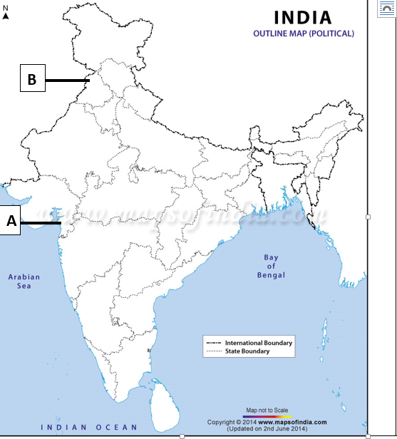

SAMPLE QUESTION PAPER
SOCIAL SCIENCE (CODE 087) SESSION 2022-23
CLASS X – ANSWER KEY

1. (c) The IMF and The World Bank
2. (c) Balgangadhar Tilak
3. (b) Cultural impact of the west
4. (b) Diamond Sutra
5. (b) 1-A,2-C,3-B,4-D
6. (c) Madhya Pradesh
7. (d) Ragi
8. (d) Dutch and French
9 (c) Horizontal division of power or power shared among different organs of the government.
10. (b) Panchayat raj bodies
11 (a) Defence
12. (d) The Election Commission
13. (d) differences of opinion about how marginalized sections are to be treated
14. (c) Per capita income
15. (b) Sri Lanka
16. (a) secondary sector
17. (b) GDP
18. (b) Paper notes
19. (c) liberalisation
20. (a) Agriculture Sector
21. Why did industrial production in India increase during the First World War?
Answer:- (i) During the First World War, Manchester was busy with war production. So their export to India declined. (ii) Because of this Indian cotton mill suddenly got a huge opportunity to supply to the home market. (iii) As the war continued, Indian mills were asked to supply jute bags, uniform for war. (iv) To meet up these demands, new industries were established, old industries started several shifts. During this time the production system boomed. (v) Downfall of British industry was like a boon for home industry: Even after the War Manchester could never recapture its old position in the Indian market. Britain failed to compete with the progress of the USA and Japan and its economy collapsed. As cotton cloth production declined in Britain, so local industrialists gradually consolidated their position in the home market.
Or
Jobbers were the people who were employed by the employers to meet their needs pertaining to working capital. Their role involved them to do following:
a. These Jobbers used to employ the workers and were responsible for the whole recruitment process.
b. These people were the trusted people of the employers. Their major role of providing workers to the industrialists required them to employ the people from their own villages.
c. They also used to provide money to these workers in the time of extreme financial crisis.
d. But, as the need of the workers grew, the domination and power of jobbers increased as they had control over the main organ of economic and industrial development i.e. the workers. After that, they began demanding favours for the recruitment and their power increased at an alarming rate.
e. Jobbers also used to help the workers to settle in the cities.
22. Describe the different steps of ‘resource planning’.
1)Identification and inventory of resources across the regions of the country .This involves surveying, mapping and the qualitative estimation and measurement of the resources.
2) Evolving a planning structure endowed with appropriate technology, skill and institutional set up for implementing resource development plans.
3) Match the resource development plans with overall national development plans.
23. “ Secularism is not an ideology of some political parties or persons, but it is one of the foundations of our country." Examine the statement with suitable examples.
Answer:-Secularism is not an ideology of political parties but is the foundations of our country because -
There is no official religion of the Indian state. Unlike the status of Buddhism in Sri Lanka, that of Islam in Pakistan and that of Christianity in England, our Constitution does not give a special status to any religion.
The Constitution provides to all individuals and communities freedom to profess, practice and propagate any religion, or not to follow any.
The Constitution prohibits discrimination on grounds of religion.
(Any two relevant Points)
24. How can more employment opportunities be created in the rural areas? Write any two ways.
More employment in rural areas can be created by taking the following steps:
1. Farmers should diversify agriculture and adopt horticulture, animal rearing, organic farming, pisciculture besides farming.
2. Government should take necessary steps to provide loans to farmers at cheaper rates and from formal sources of credit.
3. Creation of basic infrastructure facilities such as roads, transportation, market, and banking will lead to the creation of employment opportunities in rural areas.
4. Establishment and promotion of cottage and small-scale industries will also increase employment opportunities in rural areas.
5. Making provisions for education and health services in rural belts can also result in employment (Any two relevant points)
25. Salt March was an effective symbol of resistance against colonialism because
All classes could identify with salt as it was a cheap and essential food item.
(ii) Tax on salt and the monopoly over its manufacturing was a sign of the oppression of British Rule.
(iii) It would affect the British Economy. Gandhiji reached Dandi on 12th March, 1930 and violated salt law by manufacturing salt from sea water. Breaking the salt law was an apparent defiance of British authority and was a direct challenge to British Rule in India. It had a far reaching repercussion on the whole structure of colonialism
26. Coal is formed due to the compression of plant and animal material over millions of years.
The four qualities of coal found in India are
(i) Peat has high moisture content and low heating capacity.
(ii) Lignite is a low grade brown coal, soft and with high moisture content.
(iii) Bituminous coal is buried deep and subject to high temperature. It has good heating power and Is usually black in colour.
(iv) Anthracite coal is the hardest variety and has the highest heating’power.
Or
Ferrous Minerals | Nonferrous Minerals
They are Magnetic. | They are Nonmagnetic.
They weigh more. | They weigh less.
They are good conductors of electricity | They are bad conductors of electricity.
They are less resistant to corrosion. | They are more resistant to corrosion.
They are mainly composed of iron as hydroxide, sulfides, and carbonates. | They are composed of various elements and combinations.

27. Democracy accommodates social diversities:
i Democracies develop a procedure to conduct their competition. This reduces the possibility of these tensions becoming explosive or violent.
ii No society can fully and permanently resolve conflicts among different groups. But we can certainly learn to respect these differences and can evolve a mechanism to negotiate these differences.
iii Ability to handle social differences divisions and conflicts is thus a definite plus point of democratic regimes
iv Example: Belgium - has successfully negotiated differences among its ethnic population. This reduces the possibility of tensions.
28. All the three sectors primary secondary and tertiary are interdependent to each other in the following ways.
Primary sector makes possible the extraction of natural resource like iron. This iron is then taken to the secondary sector for manufacturing through the transportation system like trucks. The extraction process is supported by the financing and information technological institutions.
It is through the secondary sector that the natural resource iron is changed into other forms through the process of manufacturing. Manufacturing again need the support of the service sector in the form of engineers electricians etc. Iron is changed into iron sheets and then into vehicles for transportation.
Once manufactured the vehicles are sold through various trading agencies. These vehicles are used for providing services in the tertiary sector and at the same time support the primary and the secondary sectors to carry out their processes.
29. In the last few decades there are several improvements in technology.
In recent times technology in the areas of telecommunications, computers, internet has been changing rapidly.
Tele-communication facilities (Telegraph, telephone, including mobile phones, fax) are used to contact one another around the world.
This has been facilitated by satellite communication devices.
Internet also allows us to send instant electronic mail (e-mail) and talk (voice-mail) across the world at negligible costs.
30 The steps which were taken by French Revolutionaries to create a sense of collective identity among the French people were:
1) The idea of La- Patrie and Le-Citoyen emphasized the notion of a united community enjoying equal rights under a constitution.
2) New French flag the tricolour was chosen to replace the former royal standard.
3) The Estate General was elected by the body of an active citizen and renamed the National Assembly.
4) New Hymns were composed, oaths taken and martyrs commemorated all in the name of the nation.
5) A centralized administrative system was put in place and it formulated uniform laws for all citizen within its territory.
6) Internal customs duties and dues were abolished and a uniform system of weight and measures were adopted.
7) Regional dialects were discouraged and French became the common language of the nation.Or
Greek War of Independence mobilized nationalist feelings:
The growth of revolutionary nationalism in Europe sparked off a struggle for independence amongst the Greeks.
Nationalists in Greece got support from other Greeks living in exile.
Sympathies for ancient Greek culture.
Poets and artists landed Greece as the cradle of European civilization.
The English poet Lord Byron organized funds and later went to fight in the War.
The growth of revolutionary nationalism in Europe let to struggle for independence among the Greeks from ottoman Empire.
Finally, The Treaty of Constantinople of 1832 recognized Greece as an independent nation.
31 The economic development of a country is measured by the development of manufacturing industries by the following waysi –
Manufacturing industries help in modernizing agriculture which forms the backbone of our economy.
They reduce the heavy dependence of people on agricultural income by providing them jobs in secondary and tertiary sectors
Industrial development is pre-condition for eradication of unemployment and poverty from our country.
Manufacturing goods expand trade and commerce
Export brings in much needed foreign exchange.
Manufacturing is the process of value addition.
It also brings down regional disparities by establishing industries in tribal and backward areas.
It increases the GDP/ National Income of the country.
Any other relevant point. Any five points to be explained.OR
i. On one hand Industries lead to extensive industrial growth and expansion, other hand these are also the cause of environmental degeneration which prompt to the different type of air, water pollution.
ii. There is an increasing requirement to use a further sustainable model.
iii. Industries must produce eco-friendly products and dump wastes responsibly.
iv. Use of latest technology can help industries to control pollution and lead towards sustainable mode of operation.
v. Industries use- Reuse-Recycle-Refuse approach.
vi. If necessary, dump waste in specified places, away from the land and water sources, for example- before dumping treat well and make useful forother than drinking purpose,stop using thermal plants in some of the locations.
32 Various challenges faced by political parties are
(a) The parties are lacking internal democracy, which keeps many prospective leaders deprived of their rights.
(b) There have been dynastic successions in many political parties. This often deprives the parties of appropriate leadership.
(c) The parties something, indulge in the use of money and muscle power for winning elections. This hampers development and is against the spirit of democracy.
(d) There are not many ideological differences between the various parties. So, there is a lack of meaningful choice before the voters. OR
Regional party | National party
Regional party refers to a political party, which has its base in a particular region and has limited objectives. | National party implies a political party that extends over the entire nation, in terms of area of influence.
It can be changed and repeated in other state. | It has a permanent symbol that cannot be repeated.
Particular region only | Entire country
It should be strong enough in at least one or two states. | It should be strong enough in at least four states.
To promote regional interest. | To resolve national and international issues.

33 Banks help people to save their money in safe custody. To save their money, people deposit their money with banks.
Banks give interest on the money deposited by the people. Thus, they add to the income of the family.
Many families survive on the bank interest.
Banks provide loans to people for a variety of purposes.
Banks charge low interest rate. To promote regional interest.
Credit provided by banks is crucial for the country’s growth and economy.
Banks boost the industrial sector by providing cheap loans.
They are the backbone of the country’s trade.
Banks employ a large number of people and as such they solve the employment to some extent.Or
The credit activities of the informal sector should be discouraged because:
85% of loans taken by the poor households in the urban areas are from informal sources.
Informal lenders charge very high interest on their loans.
They try to charge more and more interest on their loans.
There are no boundaries and restrictions.
Higher cost of borrowing means a larger part of the earnings of the borrowers is used to repay the loan.
In certain cases, the high interest rate for borrowing can mean that the amount to be repaid is greater than the income of the borrower.
This could lead to increasing debt and debt trap, therefore the credit activities of the informal sector should be discouraged.
34.1. (b) Uniforms
34.2. (b) Upper classes
34.3. (a) Colonies
34.3. (b) Hand made

35.1. Three-fourth
35.2. Continuous renewal and recharging of ground water through the hydrological cycle
35.3. Low rainfall,Over use of water any other relevant points
36.1. Dutch speaking, French speaking
36.2. Four times
36.3. Apart from the Central and the State Government, there is a third kind of government. This ‘community government’ is elected by people belonging to one language community – Dutch, French and German-speaking – no matter where they live. This government has the power regarding cultural, educational and language-related issues.
37. Map question

37. | 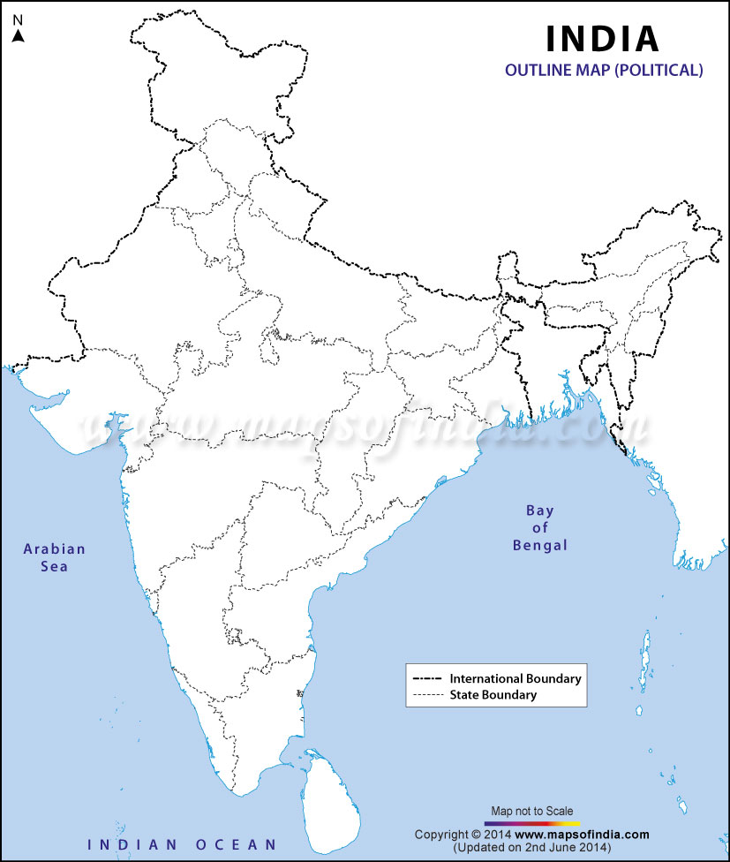  Amritsarra  Dandi  Marmangao  Narora  Bokaro  Nagarjuna Sagar Dam  B  A

